|  |
| --- |
| Close-up image showing the leaf-sides of two oversized books side-by-side on a bookshelf, with additional books in soft focus background |
| Alzheimer Pre-Diagnosis App  Supervisor : Dr. Fadi Fayez |
| |  |  |  | | --- | --- | --- | | Sushil Cherian(170007803) & Jithin Varghese(170008952) | 10/29/18 | Hot Topic in Data Analytics & Software Development | |

**Documentation Responsibilities**

|  |  |  |
| --- | --- | --- |
| **SL No** | **Documentation Section** | **Responsible for** |
| 1 | Introduction | Sushil Cherian |
| 1.2 | Solution and Research question | Sushil Cherian |
| 1.3 | MOV | Sushil Cherian |
| 2.1 | Existing Applications | Sushil Cherian |
| 2.1.1 | Existing Android Apps (4 apps) | Sushil Cherian |
| 2.1.2 | Existing iOS Apps (4 apps) | Jithin Varghese |
| 2.2 | Existing Applications Benefits and Faults | Jithin Varghese |
| 3.1 | Software Methodology | Jithin Varghese |
| 4.1 | Swift | Jithin Varghese |
| 4.2 | XCode | Jithin Varghese |
| 4.3 | Apple Store | Jithin Varghese |
| 4.4 | JSON | Jithin Varghese |
| 4.5 | Microsoft SQL Server | Sushil Cherian |
| 5 | Project Risks | Sushil Cherian |
| 5.1 | Time Constraints | Sushil Cherian |
| 5.2 | Lack of Communication | Sushil Cherian |
| 5.3 | Hardware Failure | Jithin Varghese |
| 5.4 | Lack of Experience | Jithin Varghese |
| 6 | Planning Required | Sushil Cherian |
| 6.1 | Responsibilities | Sushil Cherian |
| 7 | Gantt Chart | Sushil Cherian |
| 8 | Conclusion | Jithin Varghese |

Contents

1 Introduction 5

**1.1** **Alzheimer** 5

**1.2** **Solution and Research Question** 5

**1.3** **Measurable Organisational Value (MOV)** 5

2 Existing System and Other Applications 6

**2.1** **Existing Applications** 6

**2.1.1** **Android Apps** 6

**2.1.2** **iOS Apps** 15

**2.2** **Existing Applications Benefits and Faults** 21

3 Software Methodology 22

4 Resources 24

**4.1** **Swift** 24

**4.2** **XCode** 24

**4.3** **Apple Store** 25

**4.4** **JavaScript Object Notation (JSON)** 25

**4.5** **Microsoft SQL Server** 26

5 Project Risks 26

**5.1** **Time Constraints** 26

**5.2** **Lack of Communication** 26

**5.3** **Hardware Failure** 26

**5.4** **Lack of Experience** 26

6 Planning Required 27

**6.1** **Responsibilities** 27

7 Gantt Chart 28

8 Conclusion 28

9 References 29

Figure Contents

Figure 1- Dementia & Alzheimer's Memory Diagnosis Test 6

Figure 2 - Identifying the Month Figure 3 - Remember the given words 7

Figure 4 Reverse the word Figure 5 Select the words given above 7

Figure 6 Score based on the Answers Figure 7 Meaning of the Score and Recommendations 8

Figure 8 MMSE Start Screen Figure 9 Questions choose the right answer 8

Figure 10 Next Question Figure 11 Visual based Question 9

Figure 12 Voice based Questions Figure 13 Voice based Questions 9

Figure 14 Arithmetic Questions Figure 15 Result 10

Figure 16 Starting the test Figure 17 collecting basic information 10

Figure 18 Collecting health related information Figure 19 Collection of health history 11

Figure 20 Press the number and alphabets alternatively Figure 21 Name the Figure 11

Figure 22 Day, Month, Year Figure 23 Generic Terms 12

Figure 24 after the hearing the voice and write it Figure 25 After Audio, type those numbers 12

Figure 26 Score Figure 27 Result Assessment 13

Figure 28 My Brain Start Screen Figure 29 Initial Questions 14

Figure 30 Questions continue....... Figure 31 Questions continue....... 14

Figure 32 Complete 8th and Click on Proceed Figure 33 Result and Suggestions 15

Figure 34 App Starting Figure 35 App Questions 16

Figure 36 App's full feature is available on iPad 17

Figure 37 App Screen Figure 38 App Screen 2 18

Figure 39 App Starting Figure 40 Behaviour Assessment 19

Figure 41 Result 19

Figure 42 Questions of the app Figure 43 Result and suggestions 20

Figure 44 Suggestions continue... 21

Figure 45 Rapid Application Methodology Phases (Team, 2018). 23

Figure 46 XCode – IDE 24

Figure 47 Apple App Store 25

# Introduction

## **Alzheimer**

Alzheimer is type of dementia it is more related to memory, thinking and behavioural problems which affected human beings. Its indications used to show up early and gradual progression is the behaviour of the illness and it will be its peak such as not able to propagate the day to day activities by themselves. Alzheimer is vastly affected to humans are aged above 65 even though there are researches shows that 200,000 American youngsters are also having or started symptoms of Alzheimer. In initial stages memory lose will be very less or not event noticeable but slowly it increases and affected as well as the 6th notable causes for death in the USA. Till now no possible complete cure is discovered for Alzheimer but if it detected earlier then symptoms can be treated so that it can prolong or delayed its progression (Association, 2018). When we think about a topic we thought about it must be useful to the human community. While doing the research we have found that very less apps are present for pre-diagnosis of Alzheimer and most of the apps are either complicated or paid ones. While discussing as team and to our supervisor we come to a point that it must be simple and to the point app hence the dawn of Alzheimer Pre-Diagnosis App.

## **Solution and Research Question**

Alzheimer Pre-Diagnosis app will be improving the accessibility of the pre-diagnosis for the common people because it involves physician and their time and money. App will give them taking the pre-diagnosis at any time anywhere because of its handy nature as well as ease of use as well as at the end test will reveal the result and based on that it will advise what to do next. Alzheimer Pre-Diagnosis application must ask and answer an important question; Can building pre- diagnosis iOS app for Alzheimer will improve accessibility and efficiency?

## **Measurable Organisational Value (MOV)**

The Measurable Organisational Value (MOV) for this project is the social and economic aspects of the human community. Citizens are the assets of their own country and to the entire world. Hence, add value to the social aspects is to contribute to the wellness of the community is the social commitment to anyone. When this project go-live it will help the persons can check their level of severity and can prolong the Alzheimer for long by treating for the symptoms. Otherwise we need to book an appointment to physician and pay his fees even though we do not have the illness. Hence majority of the people used to avoid that so that treatment will be delayed and worsen the situation. Alzheimer Pre-Diagnosis app is freely downloadable app from Apple Store and can do the test by himself or care taker to a patient as and when they prefer.

# Existing System and Other Applications

## **Existing Applications**

Through our research on google we have found apps from Apple Store and Google Play store. We have chosen few of the recently developed and updated apps for our review because it will have latest style and approach for app development as well as it will be using the latest developments and updates on Alzheimer pre-diagnosis.

### **Android Apps**

#### **Dementia Alzheimer’s Memory Diagnosis Test: MMSE**

MMSE based Dementia Alzheimer’s Memory Diagnosis Test app is freely available through google play store. This app is useful for taking the test by themselves or by a care taker to a patient on memory health based on the questions provided. The test is based on MMSE (Mini-Mental State Exam) based question which could take around 10 minutes of our time and test consists of 30 questions, its results will show the intensity and development of Cognitive impairment of Alzheimer and other types of dementia. Score can be affected by the age and education of the person who undergoes the test. (alec.hewitt9@gmail.com, 2017)

Since this app is based on MMSE Test, it has 5 different types of assessments on Orientation, Word registration and recall, Attention and calculation, Language abilities and [Visuospatial ability](https://www.verywellhealth.com/how-does-dementia-affect-visual-spatial-abilities-98586). Orientation is dealing with year, month, day, date and season as well as state, city/town, country, building and floor or house no and so on. This will be scored based on 5 out of 30. Word registration and recall used in this app 3 words are given later it must be recognised from the collection of words given after some activities. Attention and Calculation applied in this application by giving starting number and rest are to be filled as given by the instructions given below the bank spaces and reverse the given word. Language abilities used to asses this app by giving some pictures and name those pictures. After that app will give score based on MMSE from 0 to 30, above 25 indicates than you do not have Alzheimer means normal but less than 19 and above 10 is considered as initial stages and it is better to consult a doctor and less than 10 indicates than it serious and need to consult a doctor. But advantages of MMSE is it is widely used screening method so that it isolates persons does not have Alzheimer but regular testing through this method will help to identify the decline trend and based on that we can start the treatment but its major disadvantages are did not have the ability to adjust the score based on age, education and ethnicity. Another major disadvantage for the MMSE method is that the current official version must be ordered through the copyright owner since 2001, Psychological Assessment Resources (Andrew Rosenzweig, 2018).

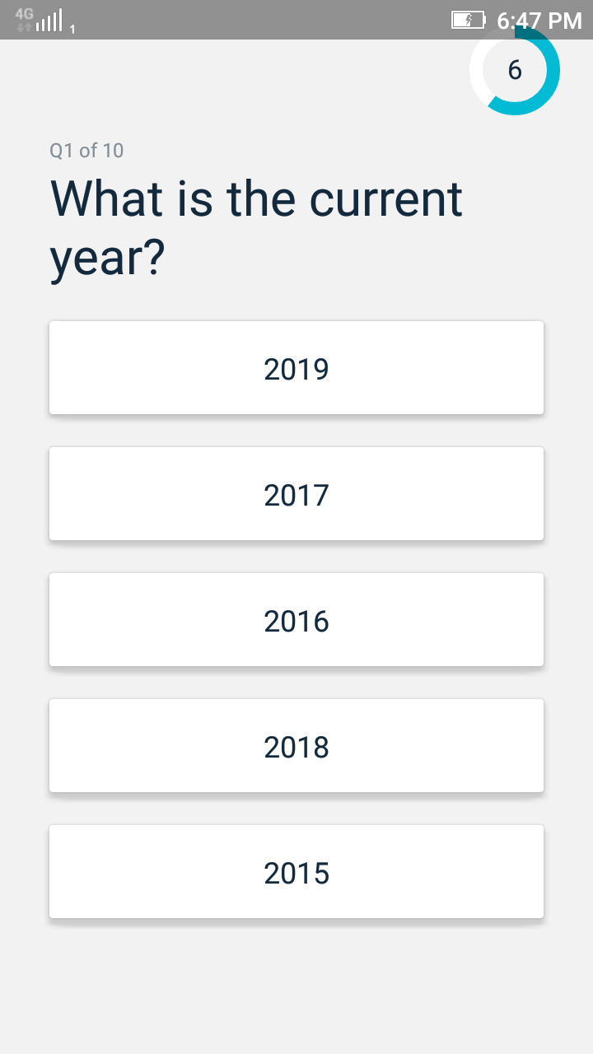

Figure 1- Dementia & Alzheimer's Memory Diagnosis Test

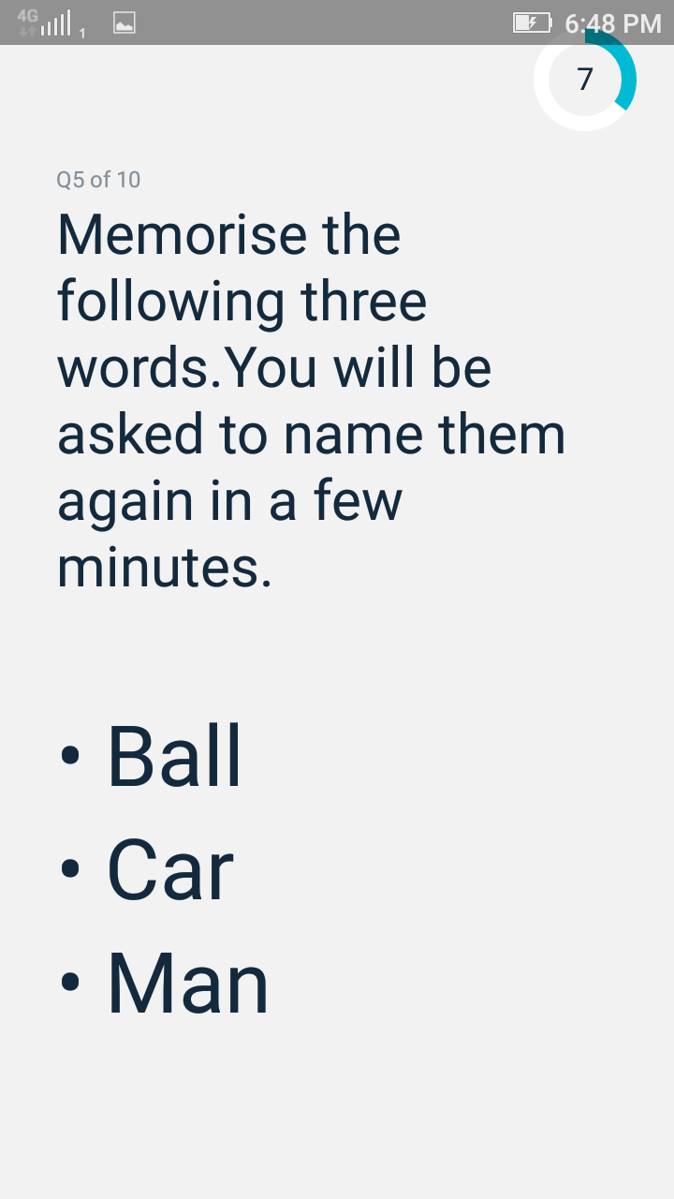

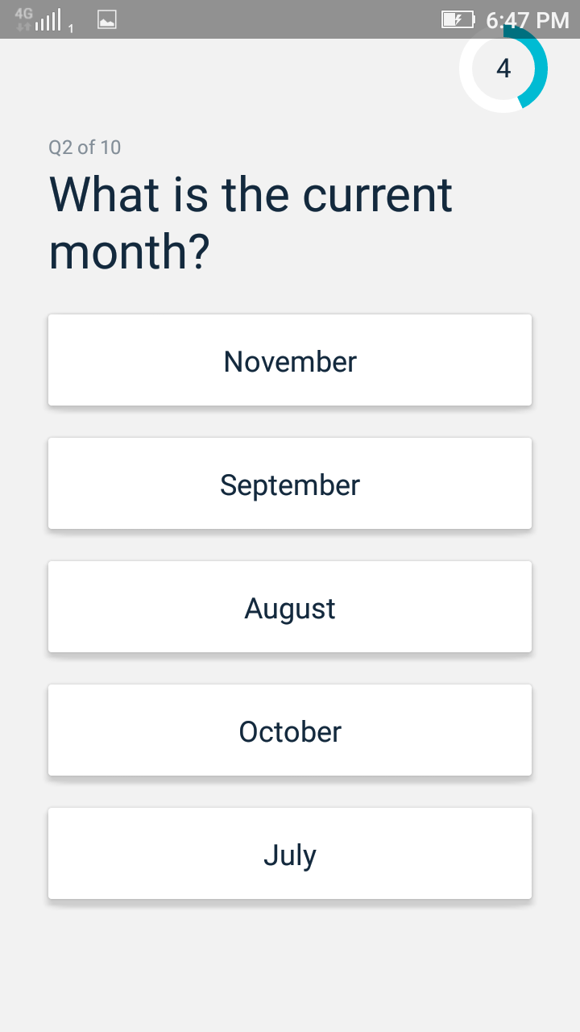

Figure 2 - Identifying the Month Figure 3 - Remember the given words

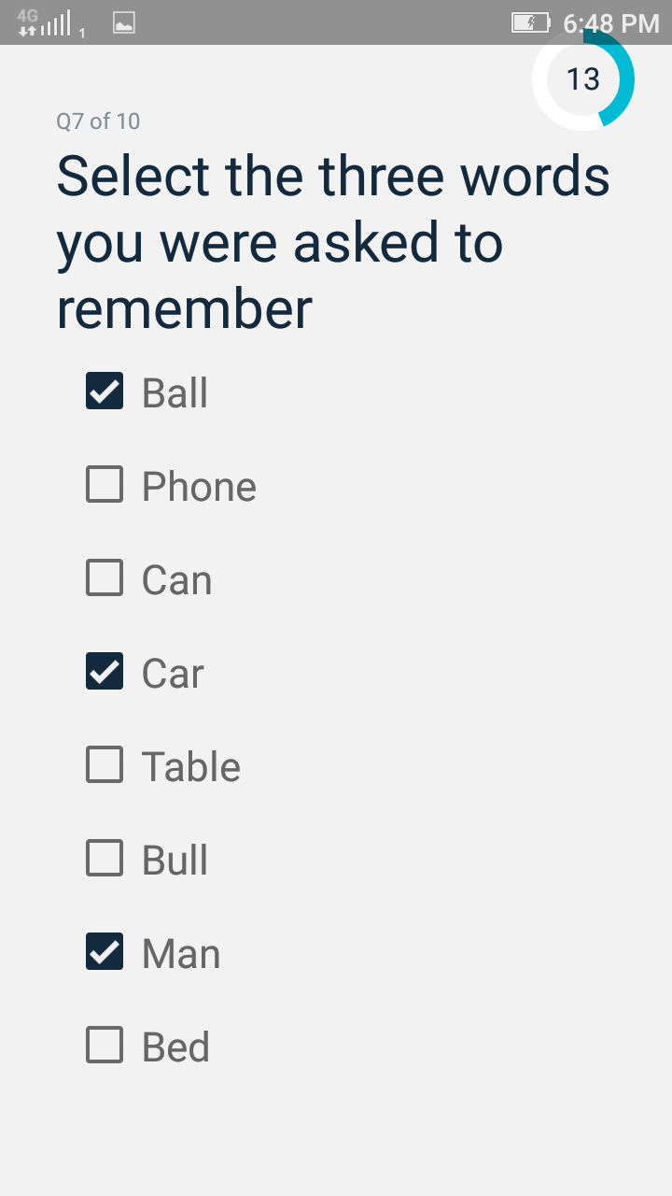

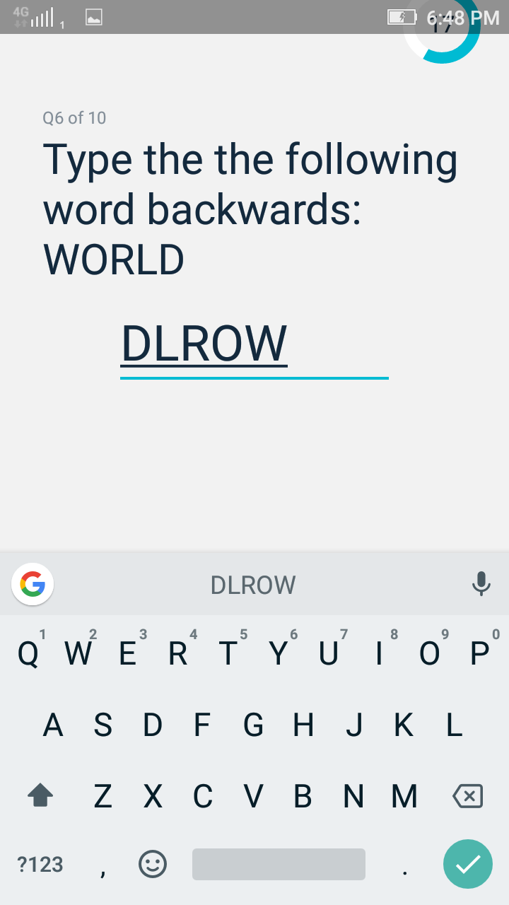

Figure 4 Reverse the word Figure 5 Select the words given above

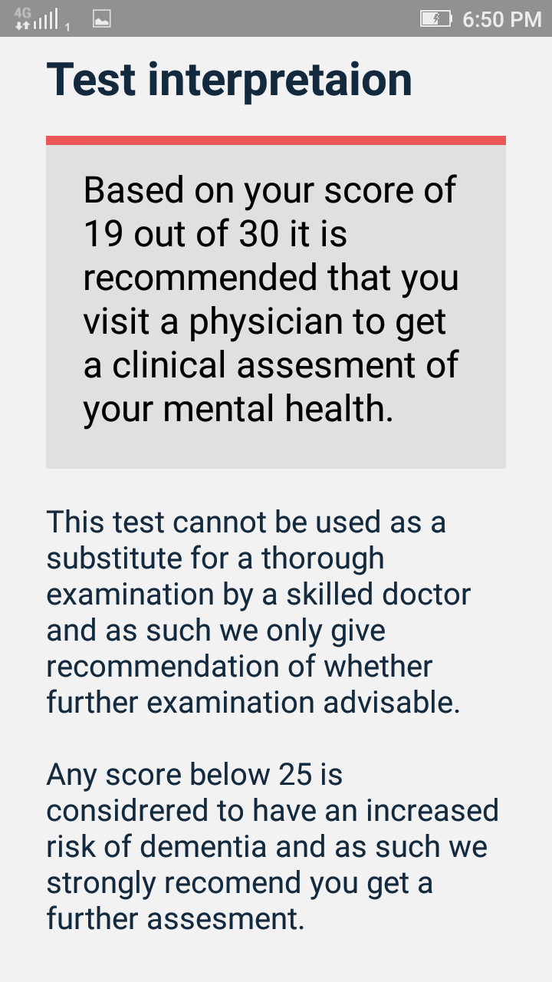

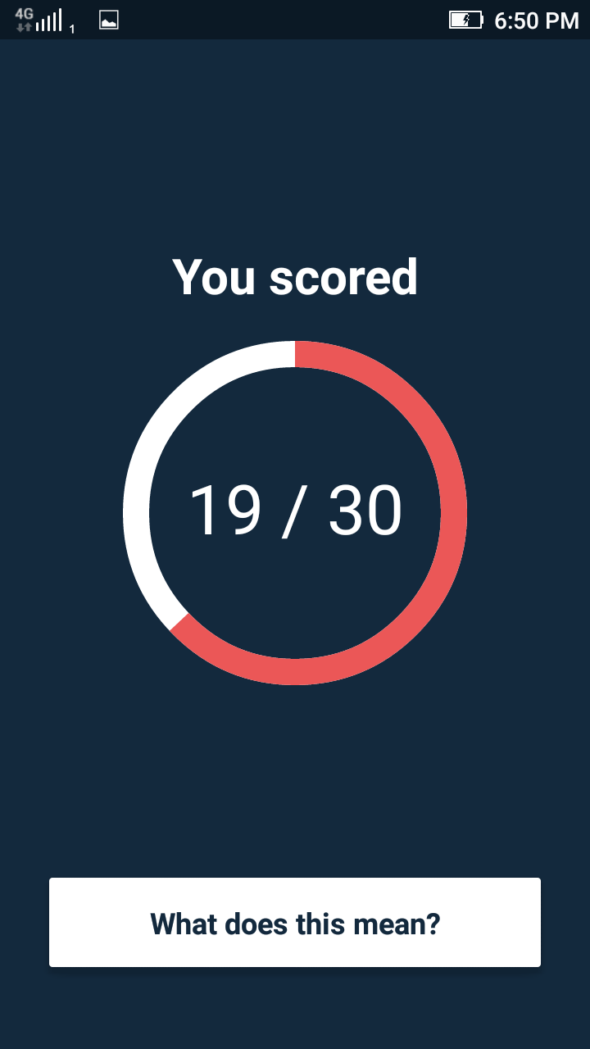

Figure 6 Score based on the Answers Figure 7 Meaning of the Score and Recommendations

#### **Mini Mental State App**

This app is again based on MMSE developed by [Yasin Tanrıverdi](https://play.google.com/store/apps/developer?id=Yasin+Tanr%C4%B1verdi) and he has added different types of questions in line with MMSE such as Text based, Image based, Voice based, Spelling based and Simple arithmetic questions. App has features such as share the test results if he wants. Then if the individuals are taking this test regularly app can give a statistical report. We can set reminders for taking test (Tanrıverdi, 2016).

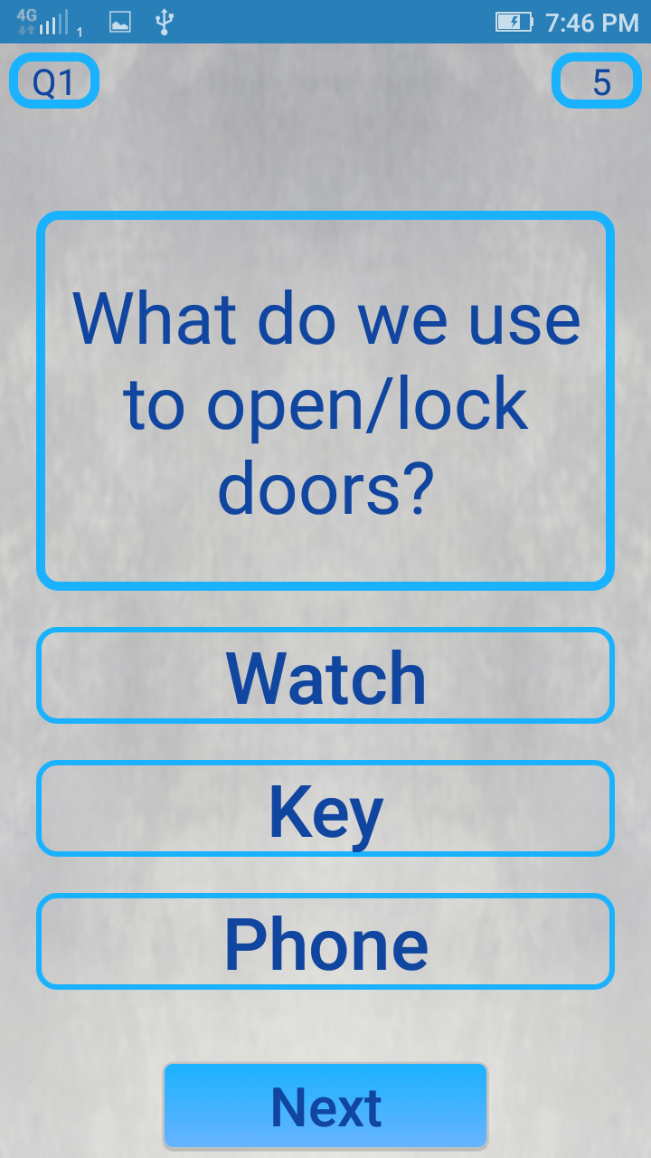

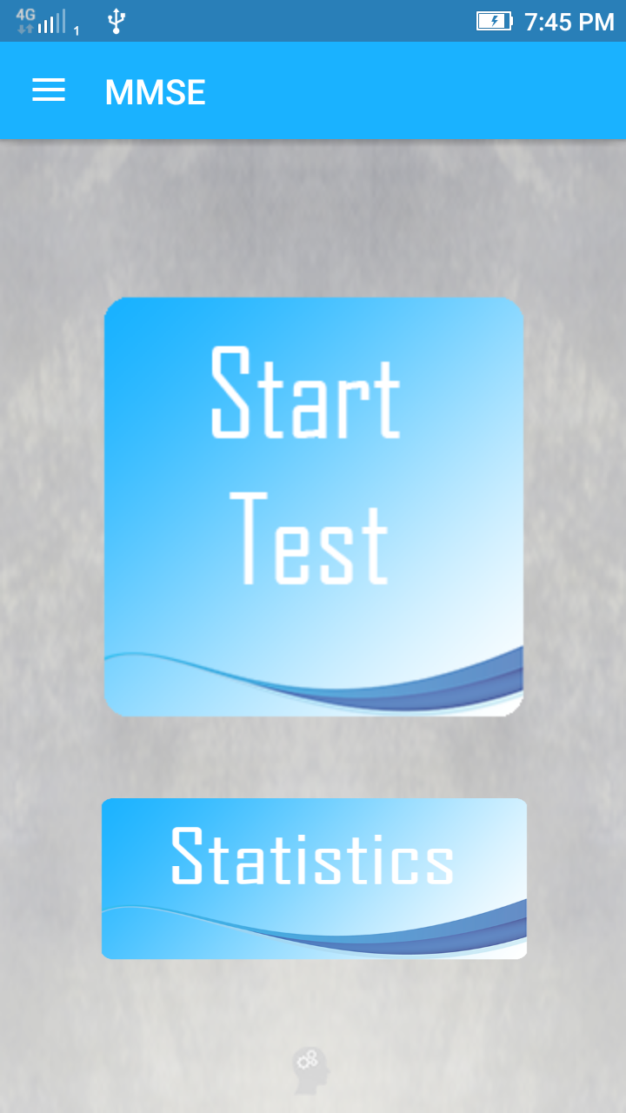

Figure 8 MMSE Start Screen Figure 9 Questions choose the right answer

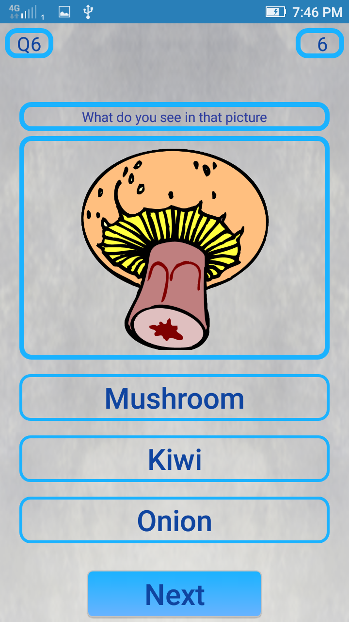

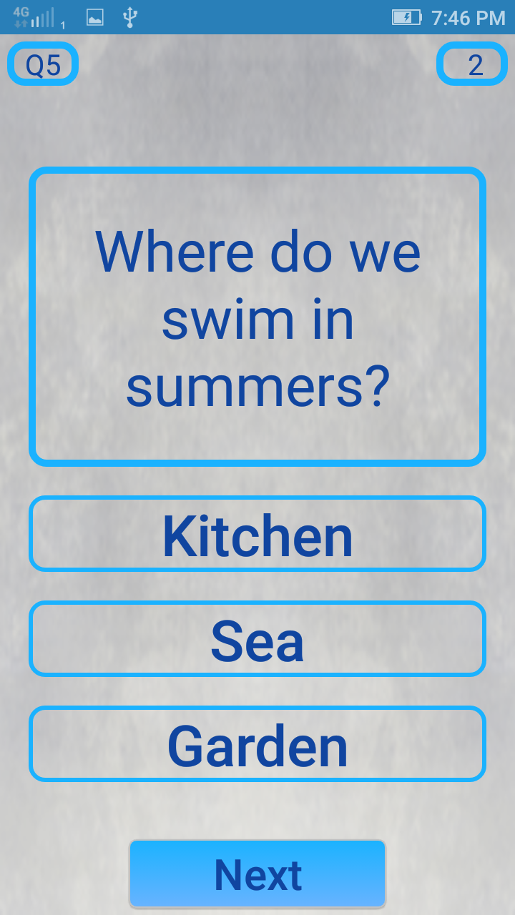

Figure 10 Next Question Figure 11 Visual based Question

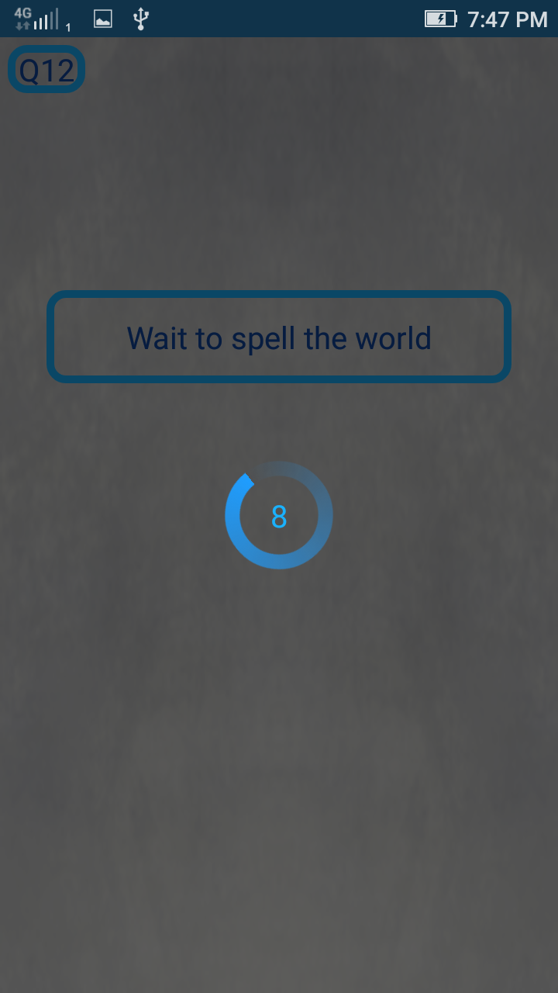

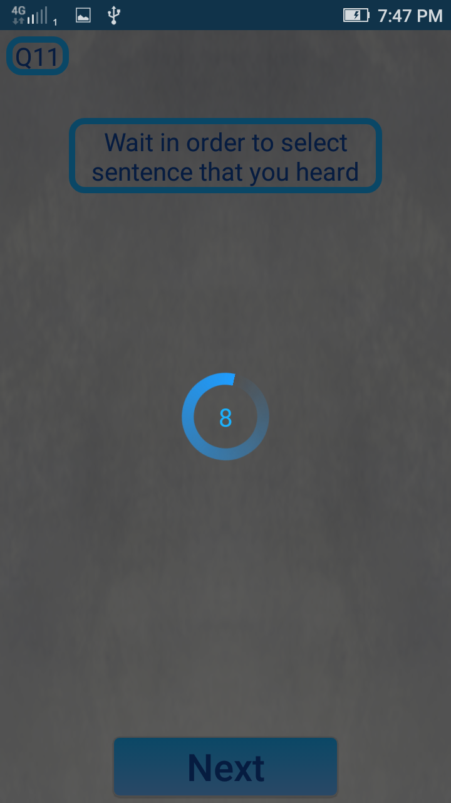

Figure 12 Voice based Questions Figure 13 Voice based Questions

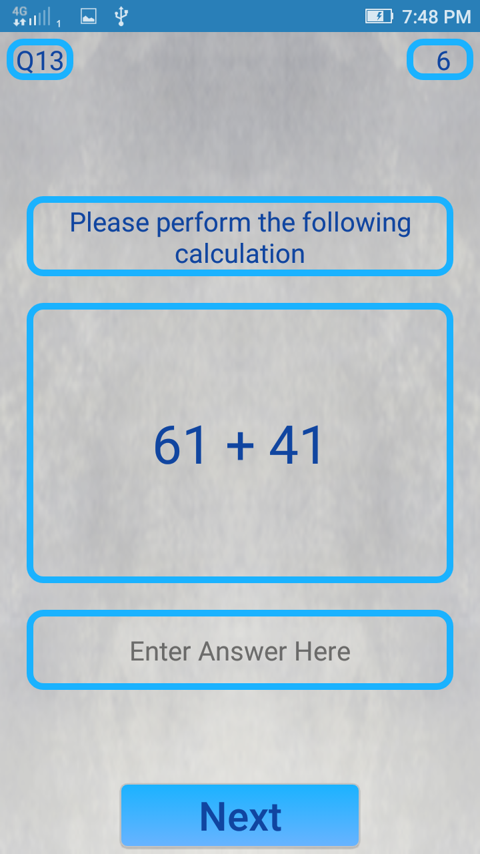

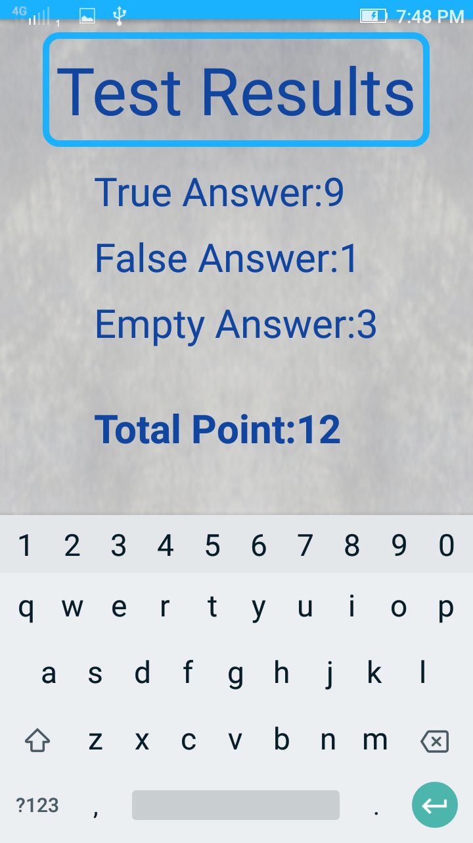

Figure 14 Arithmetic Questions Figure 15 Result

#### **SOCA Dementia Testing App**

SOCA is not based on MOCA test rather than it is firmer and choosier. This app is included with anonymous questions for the calculating the score. If the we have got good score that means we do not have dementia in any form. This app can be used by doctors for their day-to-day practice. (Wascher, 2018)

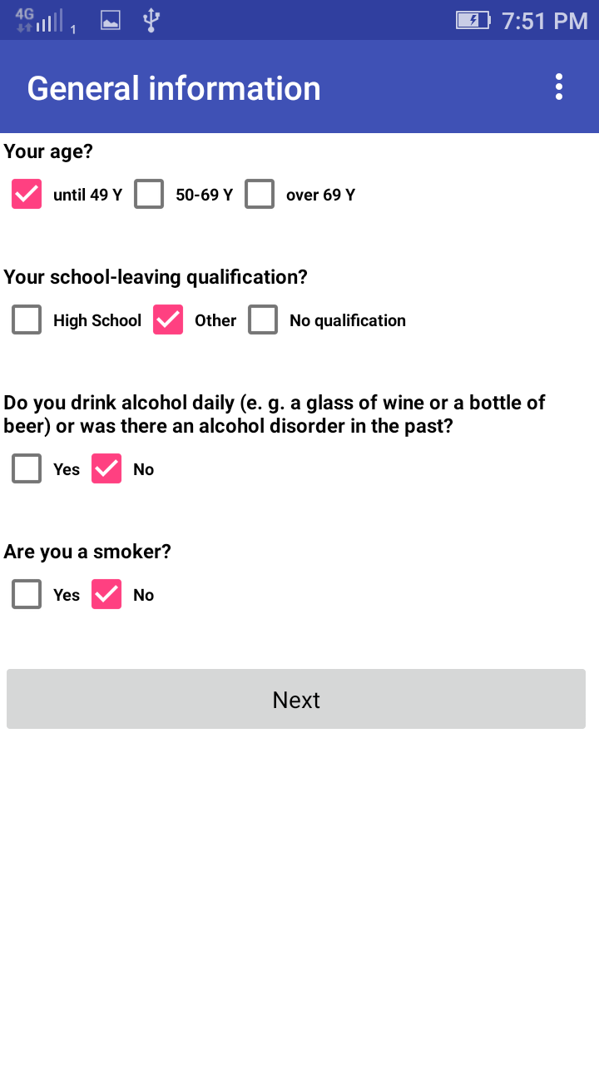

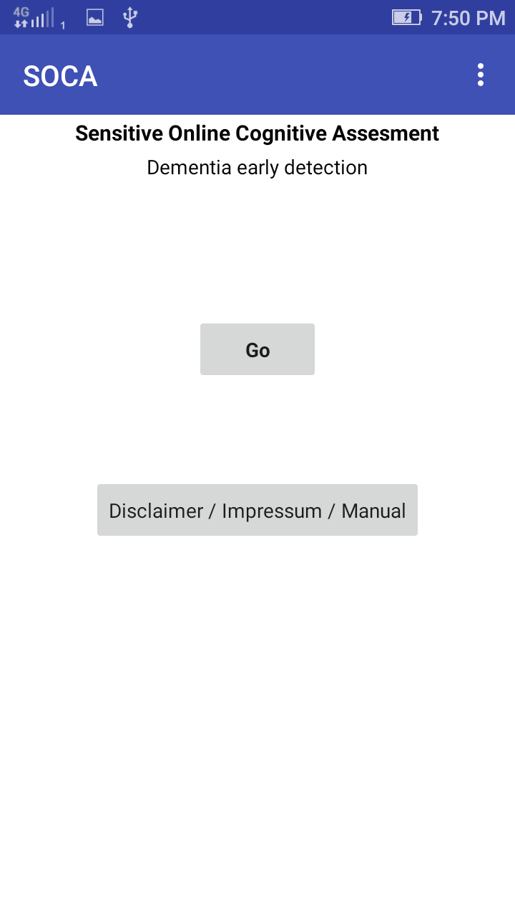

Figure 16 Starting the test Figure 17 collecting basic information

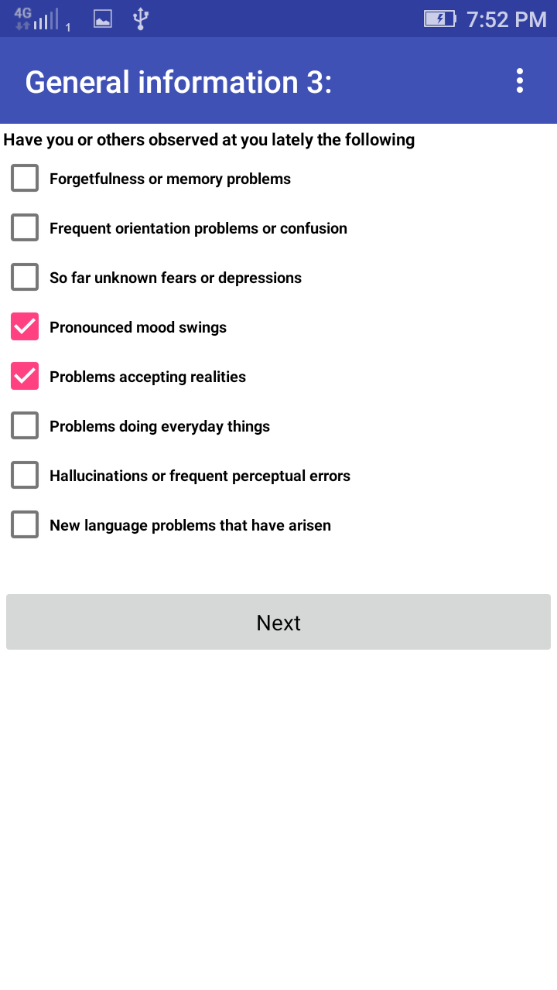

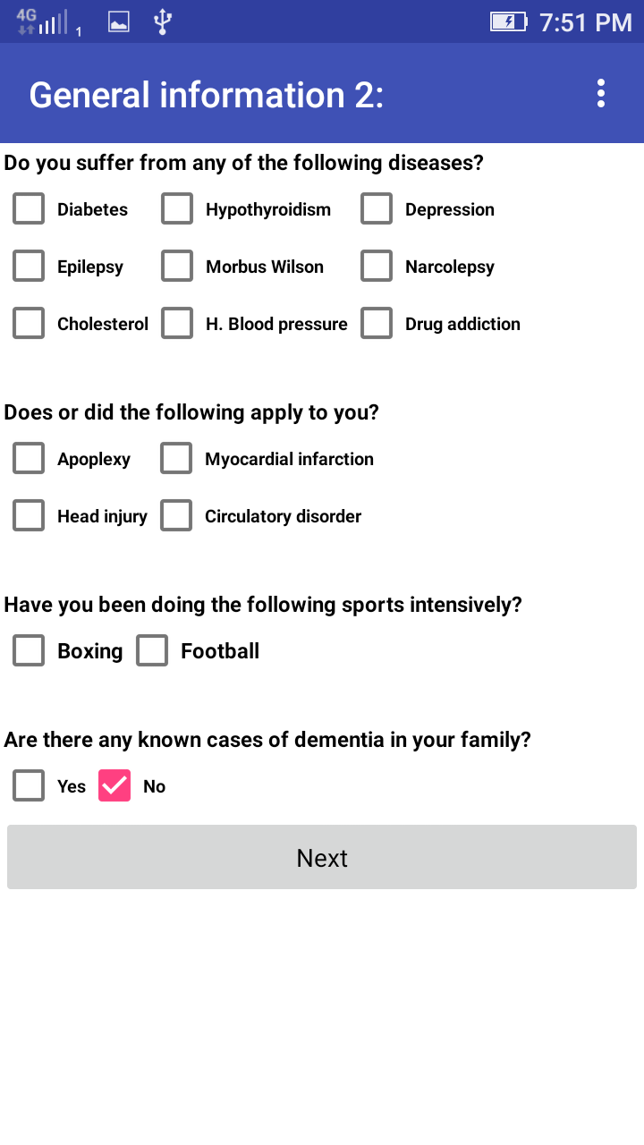

Figure 18 Collecting health related information Figure 19 Collection of health history

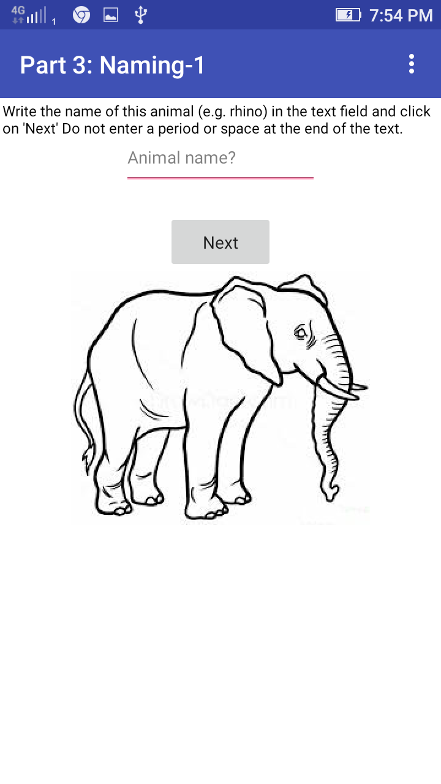

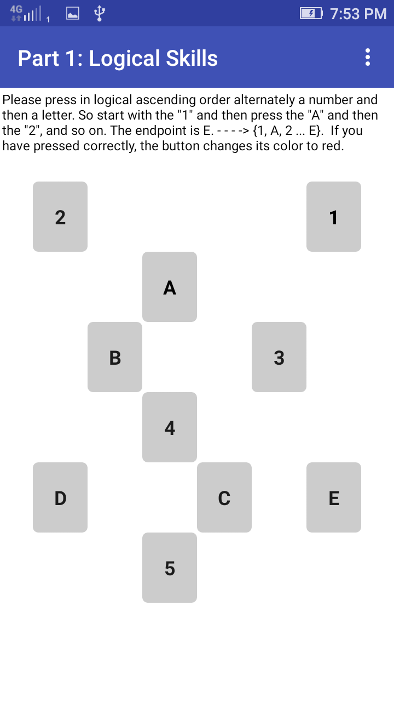

Figure 20 Press the number and alphabets alternatively Figure 21 Name the Figure

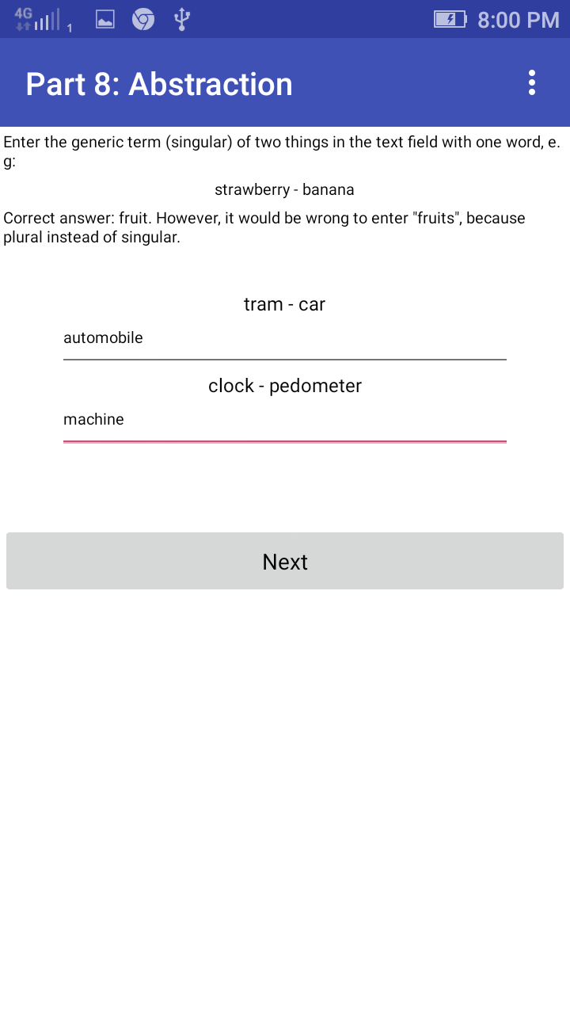

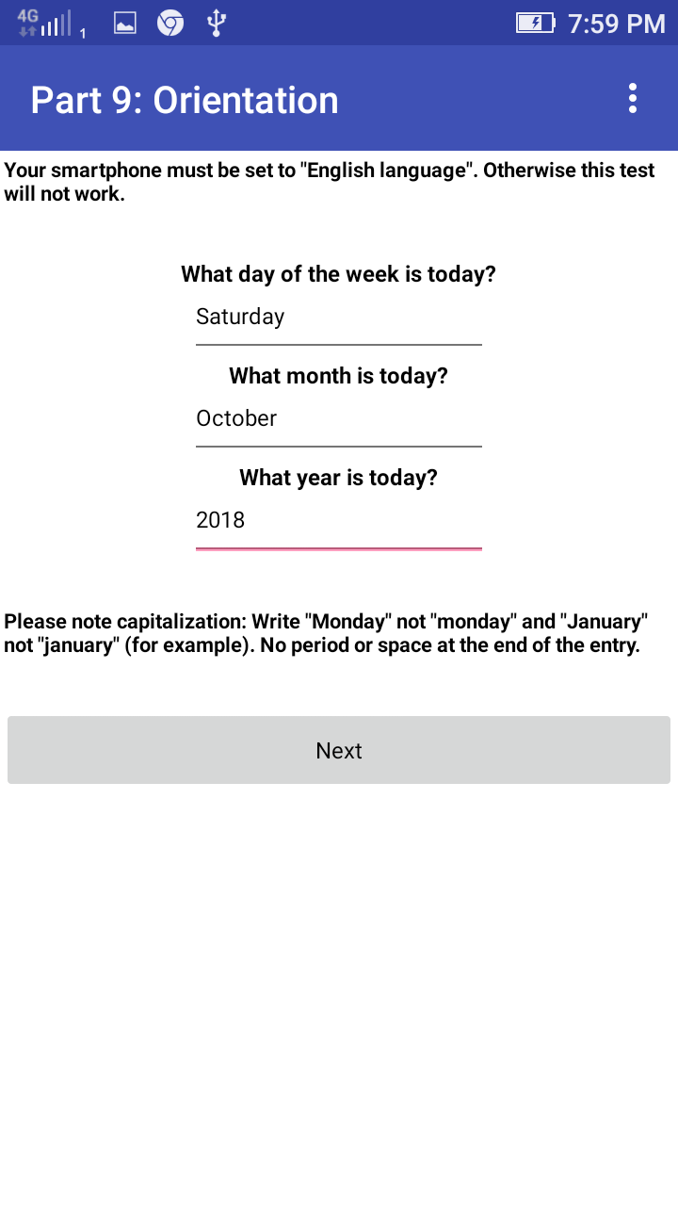

Figure 22 Day, Month, Year Figure 23 Generic Terms

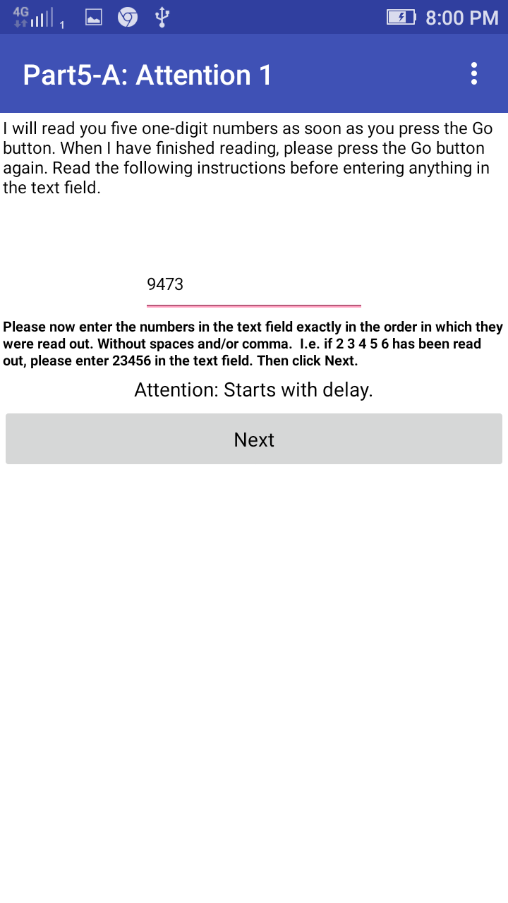

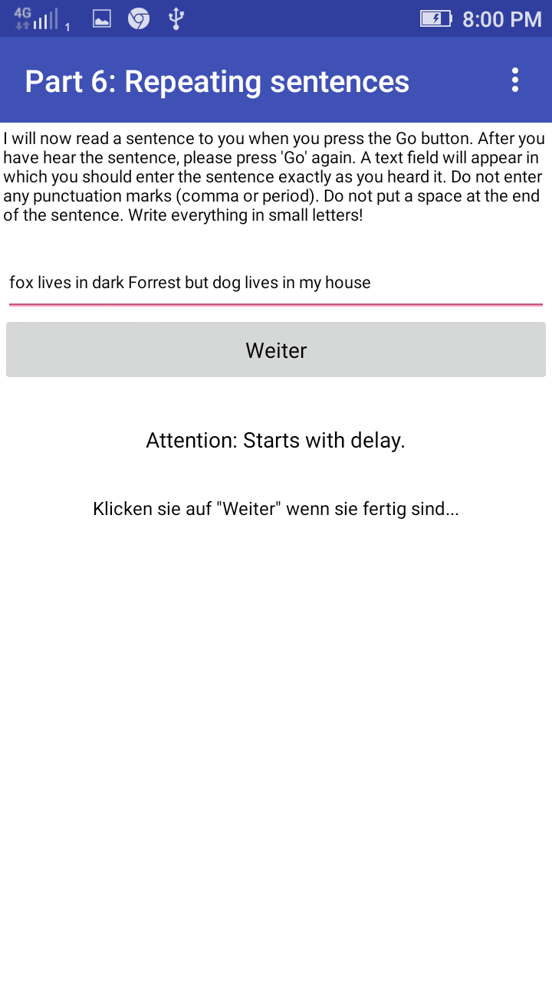

Figure 24 after the hearing the voice and write it Figure 25 After Audio, type those numbers

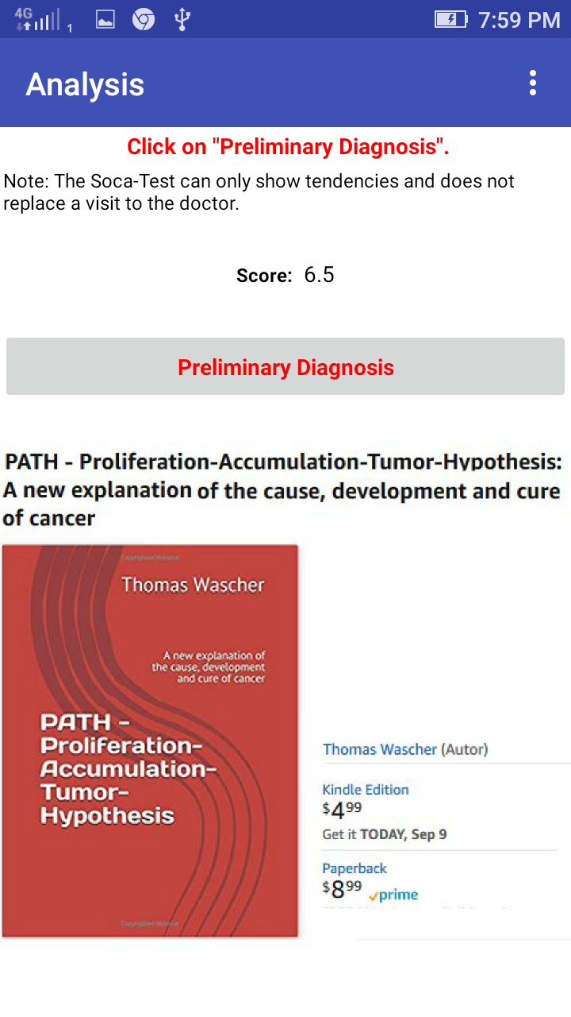

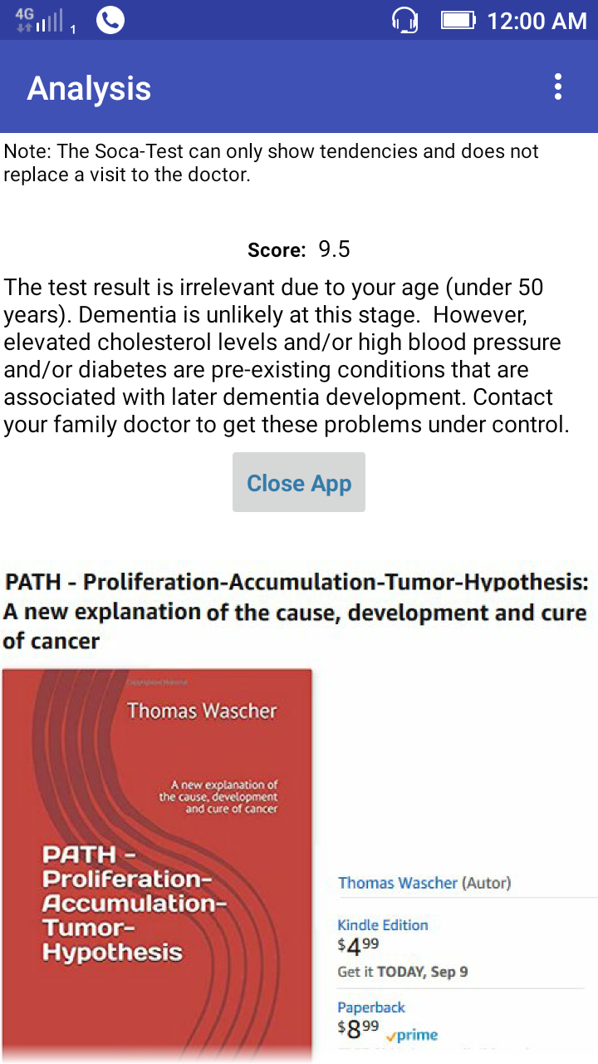

Figure 26 Score Figure 27 Result Assessment

#### **My Brain**

The app is used to find out a person has Alzheimer or not. It has different sections such as Take a Tour is to get accustomed with the app and get trained, how to use the app. Create Profile will create a profile so that when we use to test multiple times it will give statistics report using stats section of the app or else we can use the app with out creating a profile using “Move in without profile” section for taking the test. There are informative sections as well in the app such as “Doctor’s Hub” will give information on Doctors perspective such as what drugs can be used as such it does not have any cure but we extent it by treating it on symptoms and so on. “Medicine Section” gives the information about available medicines. Using “My Story” section we can share our result to some else. After that there is a “Information Hub” provides informative study on Alzheimer. Test is more or like Yes or NO type. The questions are dealing with mental stability and at the end it gives the percentile of our Mental Health as well as suggestions (Spn, 2017).

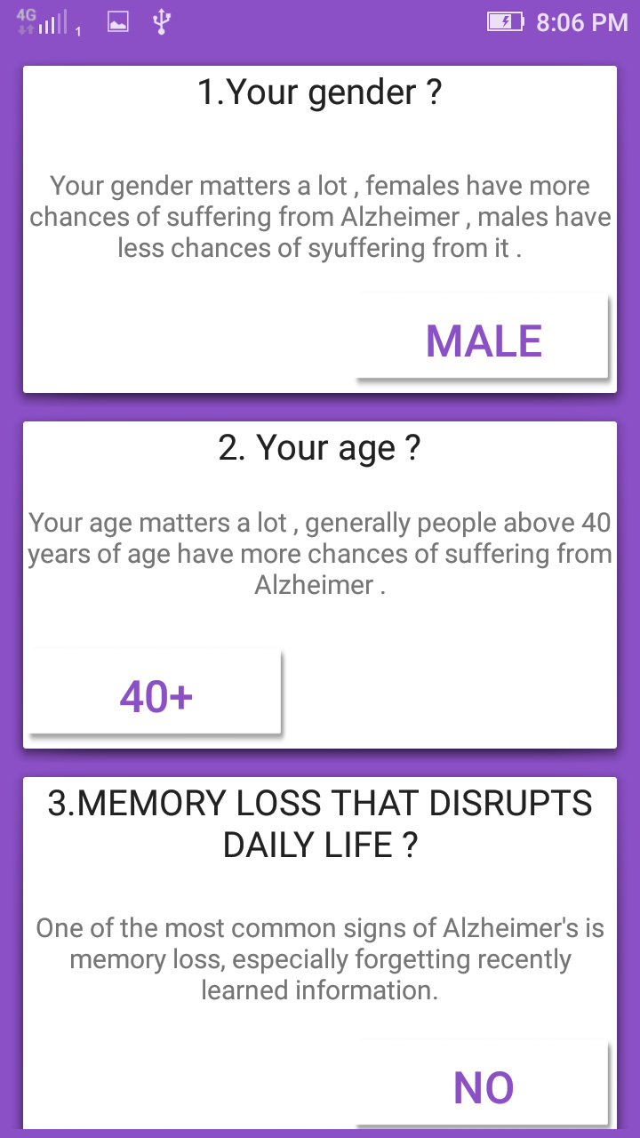

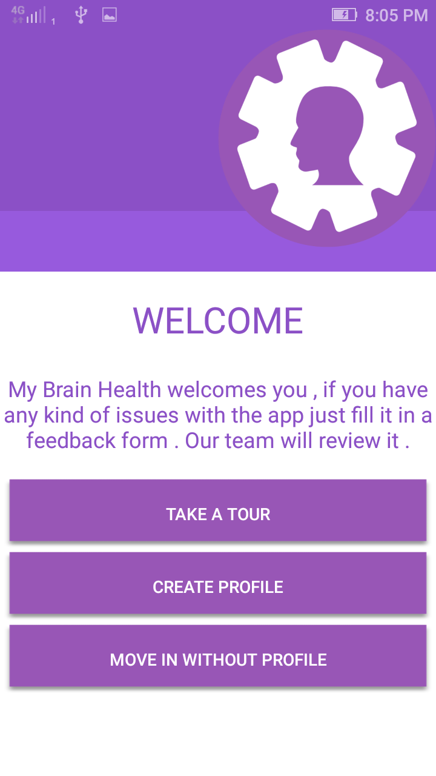

Figure 28 My Brain Start Screen Figure 29 Initial Questions

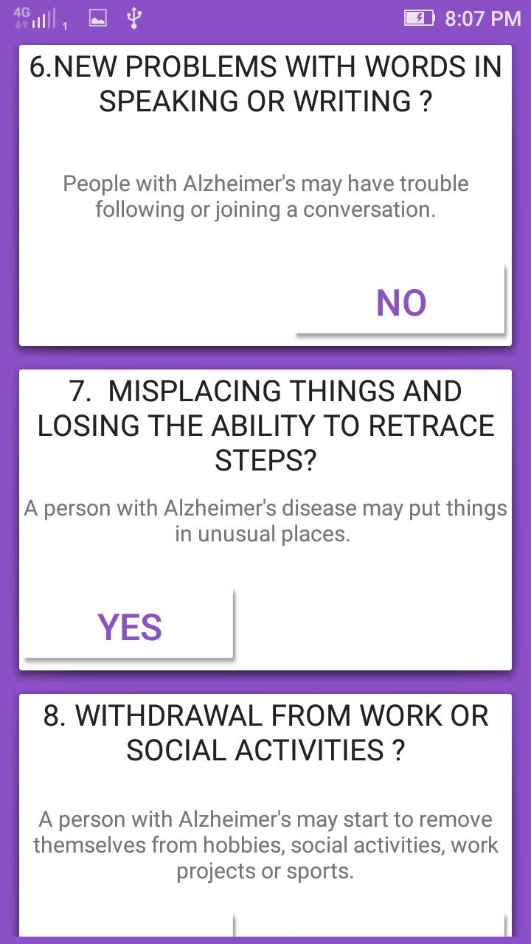

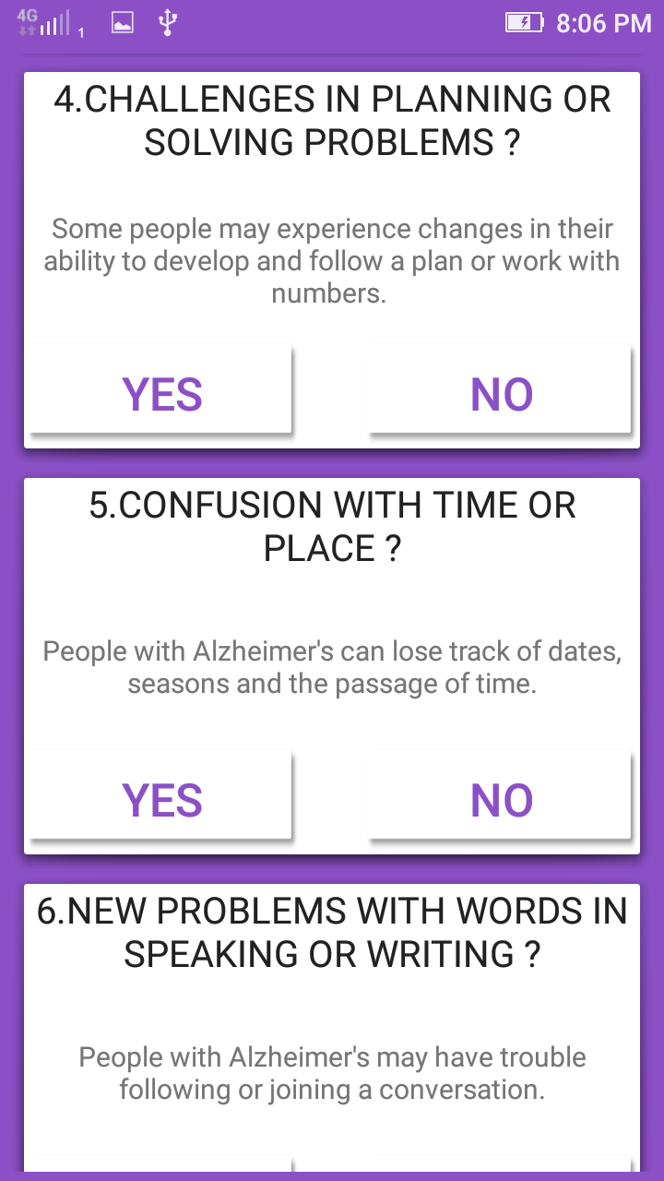

Figure 30 Questions continue....... Figure 31Questions continue.......

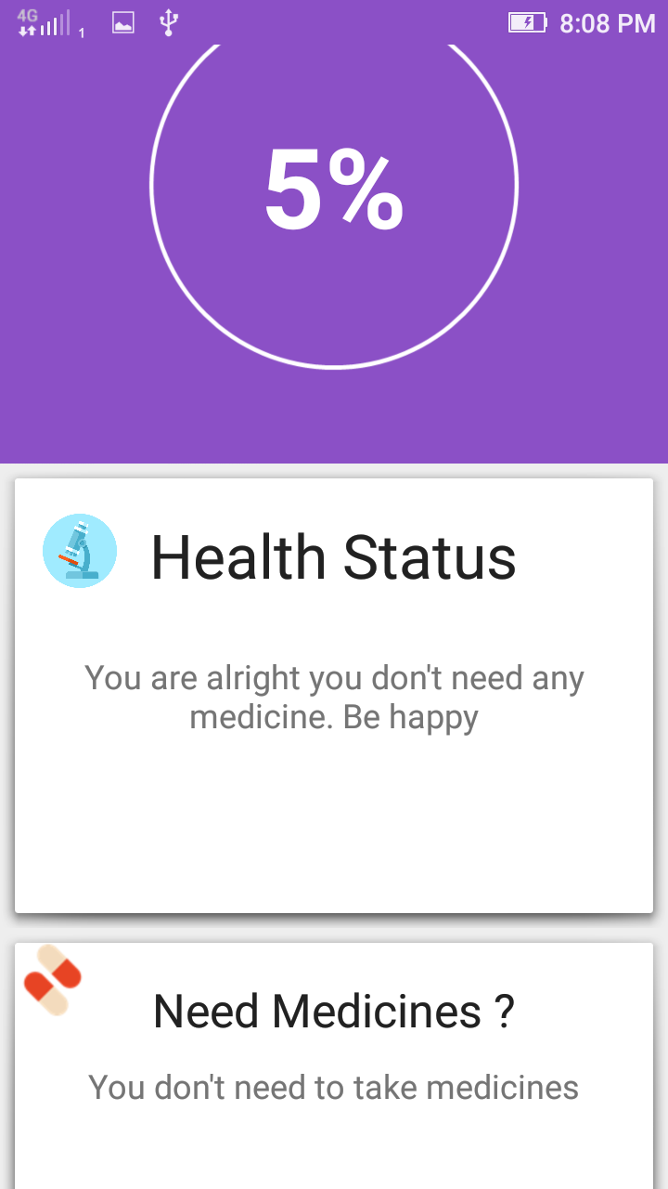

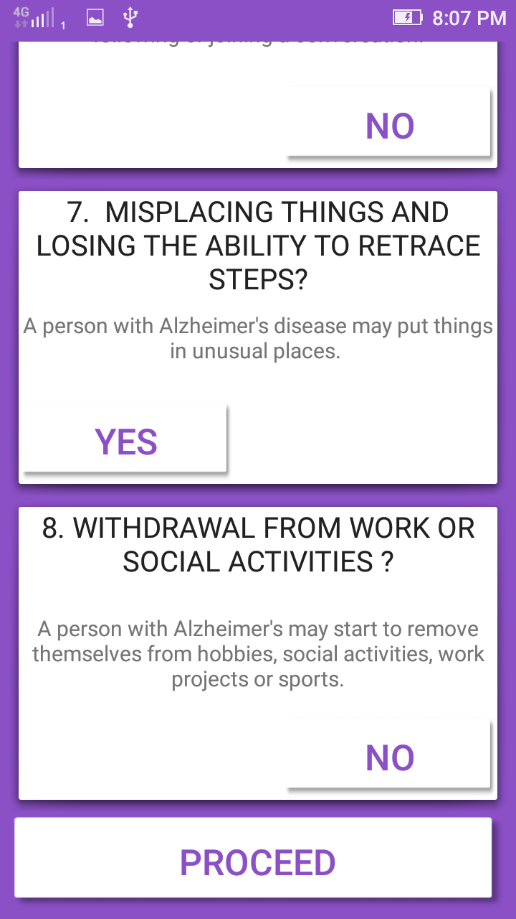

Figure 32 Complete 8th and Click on Proceed Figure 33 Result and Suggestions

### **iOS Apps**

#### **Alzheimer’s Disease Pocket card**

This app helps the physicians and other health care professionals care for patients with Alzheimer’s Disease at the point of the care. This app has clinical based information on Alzheimer’s Disease and have interactive tool to help the efficiency of the clinical tests that can be assess by the patients and the care taker. This app main advantage is that it is collaboration between the Alzheimer’s associations and Borm Bruckmeier. Main advantage of this app, if you give email address it will provide the education and support details from Alzheimer’s association. It also used DSM 5 guidelines and criteria. To help clinicians they have developed an algorithm for visiting annually with the help of professionals. (LLC, 2017)

Even though there are many traits of applications, but it is very completed and not an easy app for a layman it requires health care professional assistance. App is not user friendly and it follows an out-dated designs navigation always are very confusing it doesn’t go back to the original positions. And some of the features and not available in iPhone they are forcing the user to move into the iPad.

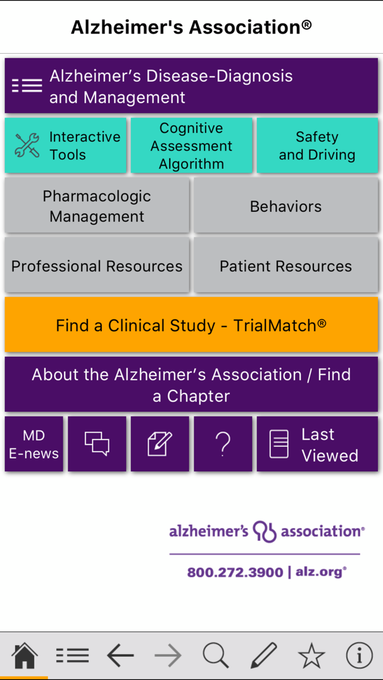 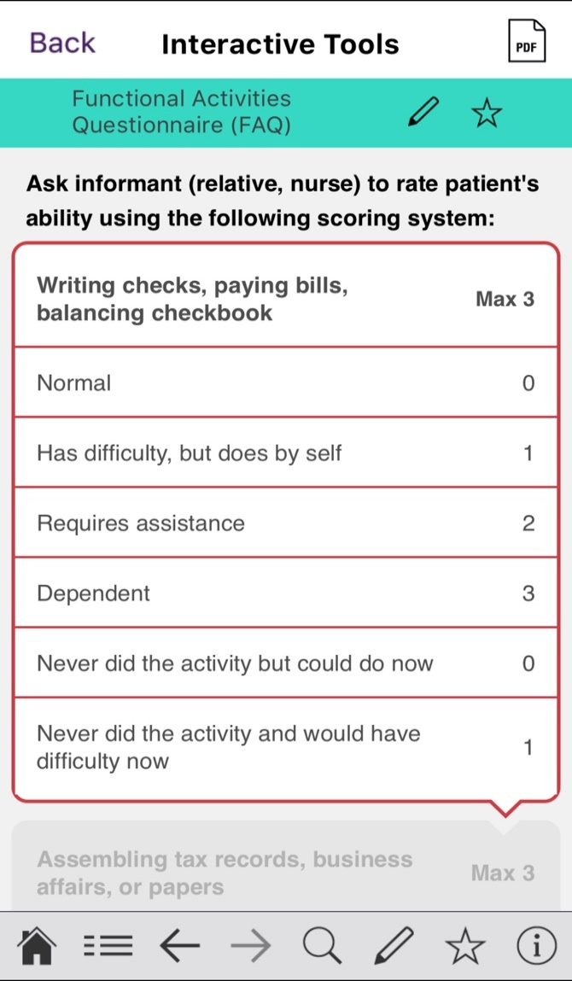

Figure 34 App Starting Figure 35 App Questions

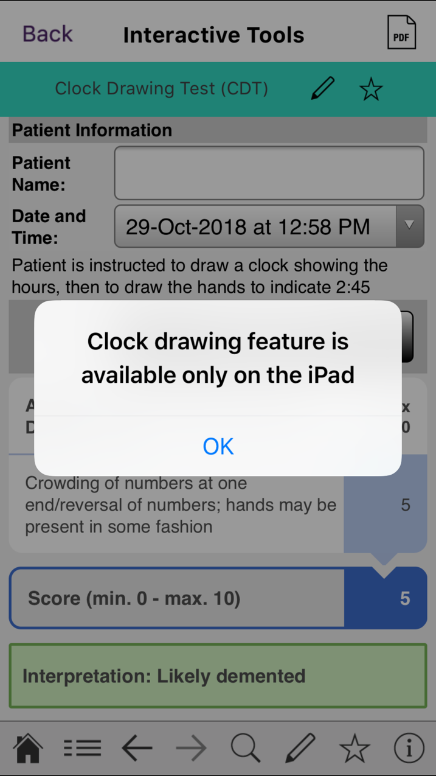

Figure 36 App's full feature is available on iPad

#### **Alzheimer's and Dementia Tips for Families**

This app is to help the families by providing Alzheimer's and Dementia video tips, so that they can advise the caregiver of Alzheimer's and Dementia patients.it have heaps of topics and questionnaires practical advice videos which helps the caregiver. By watching the videos, the family members of affected patients will get educated more on Alzheimer's and Dementia disease and its behaviours pattern of the patient. (Ericksen, 2016)

Even though app is informative it doesn’t contain any pre-diagnosed methods or screening test which helps to assess the patients’ health improvements. This app is not dynamic, it downloads all the videos within the app, it makes the app to load more time and it effects the memory if app as well as the storage capacity of the application.

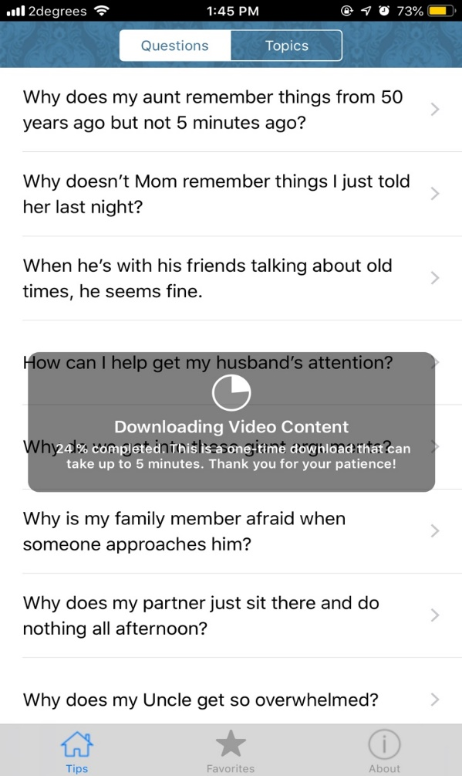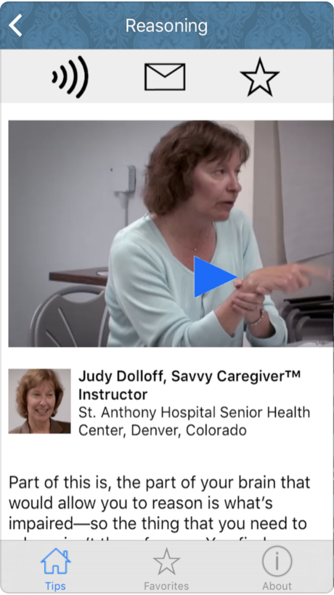

Figure 37 App Screen Figure 38 App Screen 2

#### **DementiAssist**

This app is mainly focus on the person with dementia. This app is containing many behaviours, possibly caused suggested actions of the person with dementia. It all so cover all the behavioural expressions, so that care taker and notice the patient possible behaviours expressions. This also provide the actions that to be noticed. The most unique of this app is that this app shows about the behaviour’s expression of person with dementia. It helps the healthier person to observe the expression and understand the health state (CENTER, 2015).

Even though they provide the actions for triggers, it will be great if they add more detail for the actions, in this app most of the actions a one-line sentence, which some time are not much clear to the care taker. This is app is last version release was on 3 years back, it will be good if they update periodically which helps the app improvement and design.

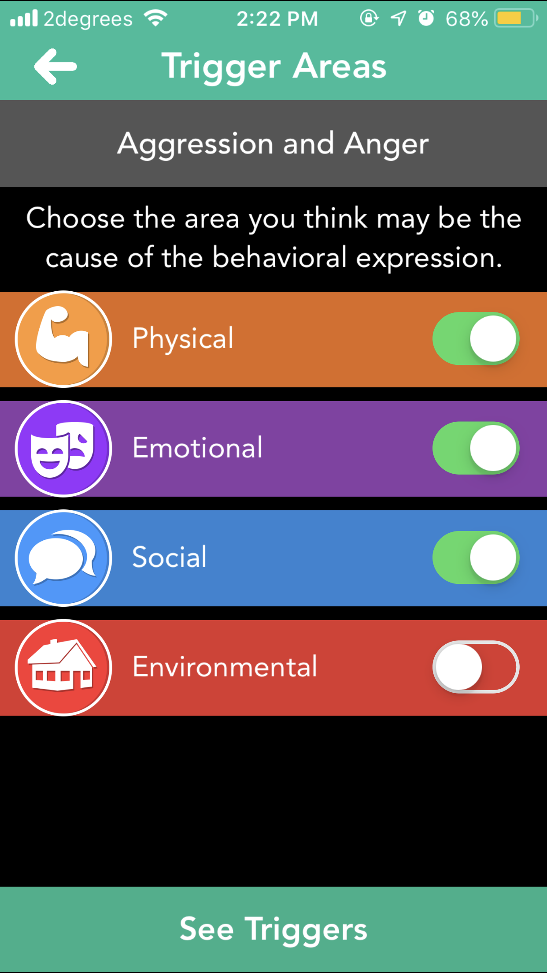

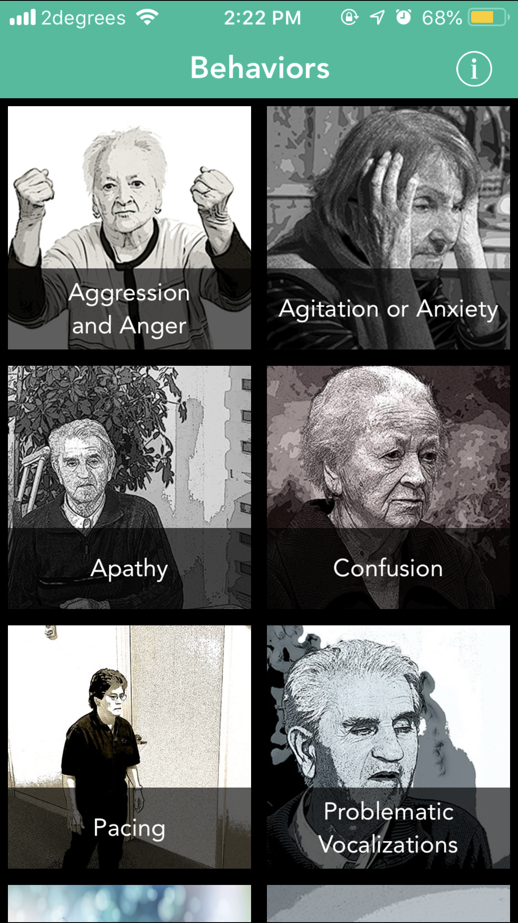

Figure 39 App Starting Figure 40 Behaviour Assessment

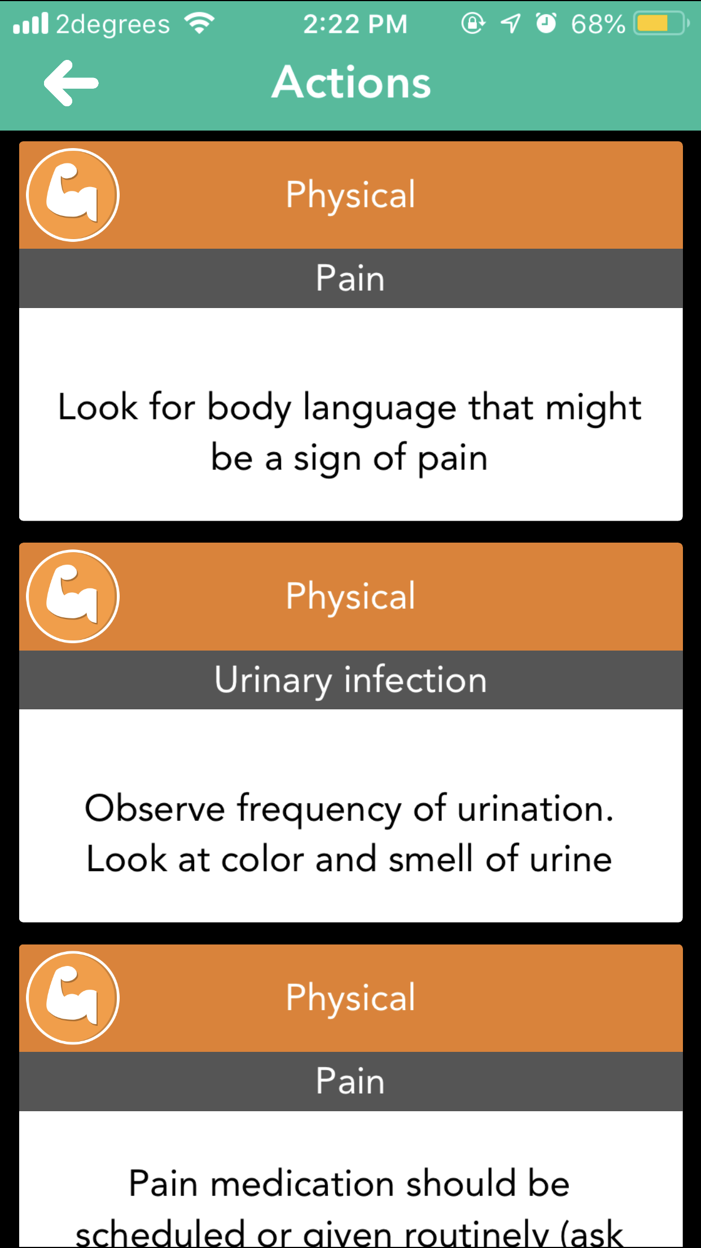

Figure 41 Result

#### **Dementia Test - risk calculator of dementia**

This app mitigating complex evolution of early dictation if dementia, which uses complex and fusion of algorithms used to develop the test. The app is using different aspects and variety of methods to access the severity of dementia. The App questioner is based on YES or NO answers and more of memory, behavioural, physical aspects of one life assessments, the overall apps orientation looks good. (s.r.o., 2017)**.**

The app font is very small, so it effects the readability of the questioner. Over all apps look and feel is very bad. It takes time to when user select the answer to move to the other questions

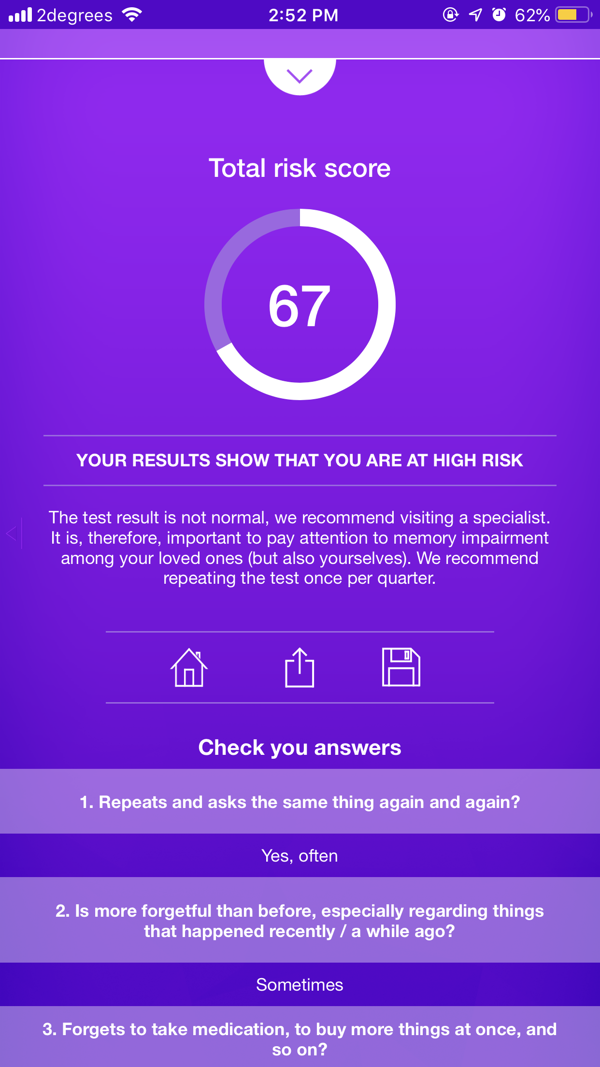

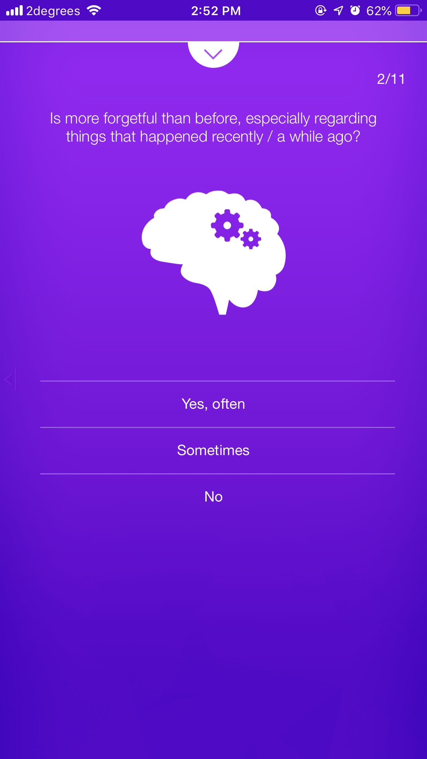

Figure 42 Questions of the app Figure 43 Result and suggestions

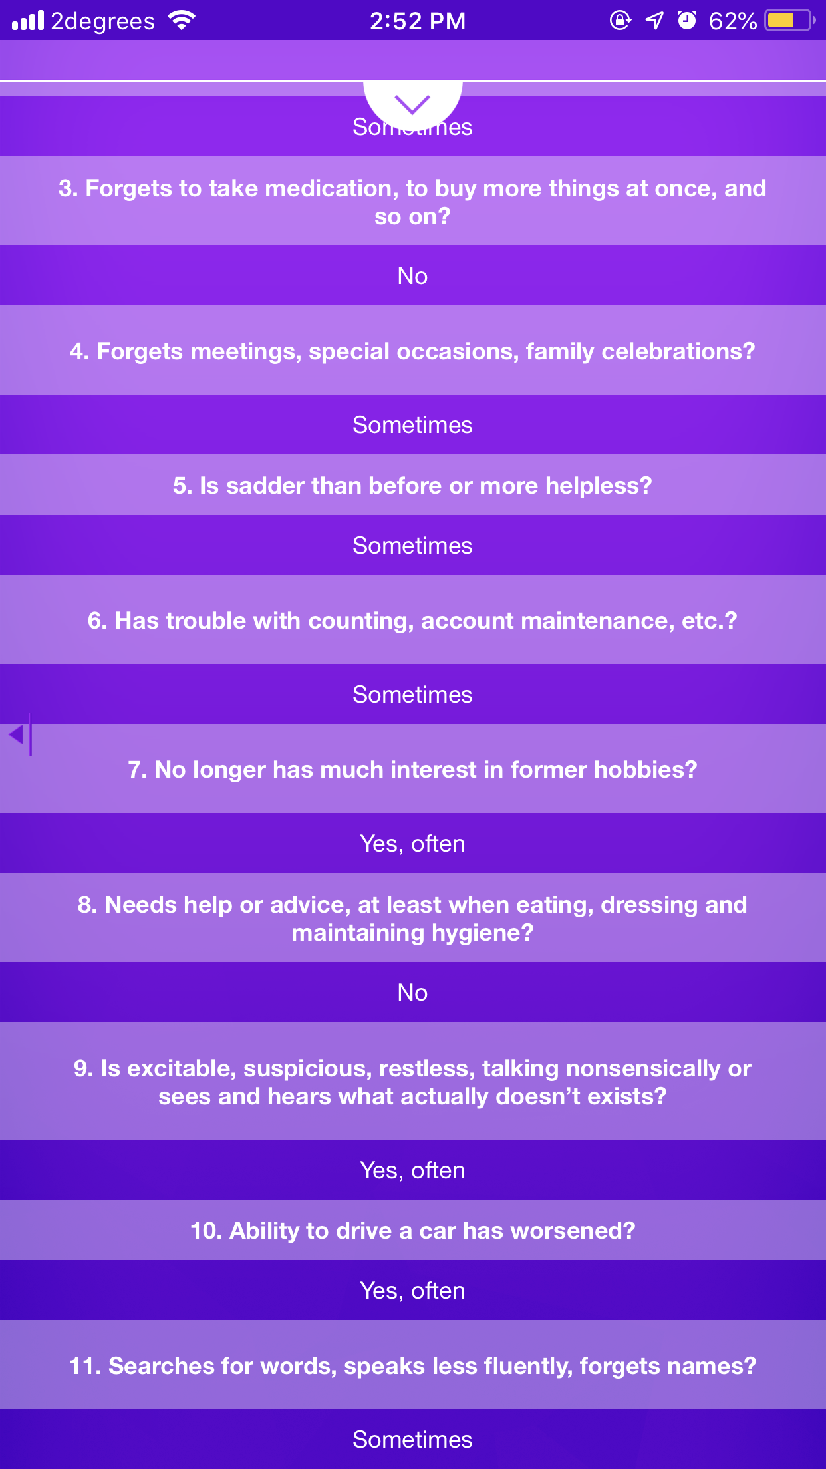

Figure 44 Suggestions continue...

## **Existing Applications Benefits and Faults**

Android apps are based on MMSE and static questions, we are planning to bring more complex questions in simple manner and easy to use, using the combination of visual and voice effects. More over our questions will be dynamic and we are planning to store the data in the database which can be use full for analysis. We are using GPCOG method which is six questions-based screening tests where user can share the report to his/her someone of his choice.

In Apple App store there are fewer Alzheimer’s apps and they are paid, we also came to understand that some app like Dementia Test - risk calculator of dementia is not following any DCM-5 standards. But we would like to take the orientation of that app to improve in our apps. We are planning to publish our app in app store for free, so it can be use full for the public

# Software Methodology

A software methodology is kind of framework that’s is used for software development which helps to do the developing in structure, plan and control the process of developing (Professionals, n.d.). Using software methodology, we will get a tracking of the development of the software.

There are plenty of process out there to manage or develop a software, thus it is impossible to find a way of development. Software methodology will reduce the risk of project by cutting down the process into smaller, this will help to develop the software easier and easier of changing the development any time (alliancesoftware, n.d.).

It is very hard to find which methodology we must follow the development, but it can be solved by understanding the all the software development methodology. Working under a development methodology will help the client and the developer to deliver a well-organized software and well discipline code.

We have decided to choose Rapid Application Development (RAD), is a form an agile software development, which works on user feedback and strict planning and freezing the requirements. In short, we can say Rapid Application Development (RAD) is “less talk more action “. But it needs more testing for the software because it is built in fast paced environment. (Anderson, 2017)

RAD is mainly focus on the software development rather than the planning, requirement is generally freeze so that it helps to start the prototyping. RAD methodology generally breaks the project into small task, where it can be accomplished more quickly. As a result, this will give effective communication, faster development and better efficiency. (Team, 2018)

**Generally, Raid Application Development focused follow four main phases**:

1. Requirement planning:
2. User design
3. Rapid Construction
4. Cutcover

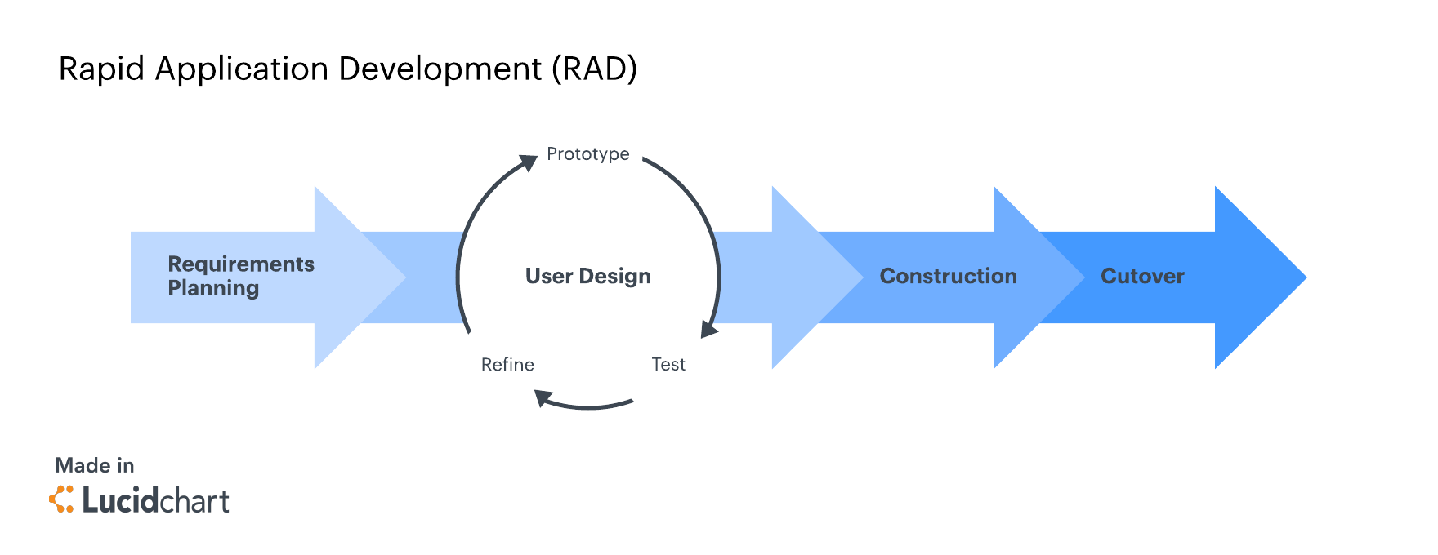

Figure 45 Rapid Application Methodology Phases (Team, 2018).

1. **Requirement Planning**

This is critical step because in RAD there is no regular meeting for the requirement planning, when a meeting is called client, developer and design will come together and discus about the project and break down the stages that involves in the project. They make sure to freeze the project so that they can start the prototyping the project. (Team, 2018)

1. **User Design**

So once the requirement is fixed, they jump into the development and start the prototyping the various design. This will be working more closely with client, to make sure developer are meeting the all the requirement and changes that client needs. (Team, 2018)

1. **Rapid Construction**

After the design meeting all the requirement it’s the time to start the rapid development, in this stage the development will be in fast pace. The software development team start the coding, integration and testing and work together to make sure everything goes as per the plan. This stage is very important because client get the beta application where he can make changes or rise and issue before it goes live. (Team, 2018)

1. **CutOver**

This is the last stage of the development, where is product comes in finished state and move to live environment. In this stage product will be moved into the new system, data conversions, and may also give training to the users. (Team, 2018)

# Resources

## **Swift**

iPhone use iOS as the operating system which is created and developed by the Apple Inc. To develop an iOS mobile application, we use SWIFT as the languages. Swift is open source modern language which works in high performance and powerful. Swift is also replacement of C – based language. (Apple, About Swift, 2018)

## **XCode**

The Integrated Development Environment (IDE) that used for the iOS development is XCode. XCode is developed by the Apple Inc., using XCode we can also develop application for MacOS and iOS application (iPhone, iPad, iWatch). Using XCode we can develop, Test and publish the application into the iPhones. This Tool are used for apple products development which have many features that helps the developer to build first class apps to the users.

Some of the futures are (Apple, features, 2018):

* Simulator
* Compelling and Easy Fix it
* Graphical debugger and Data Recording
* Direct repository
* Unit Testing and Unix tools

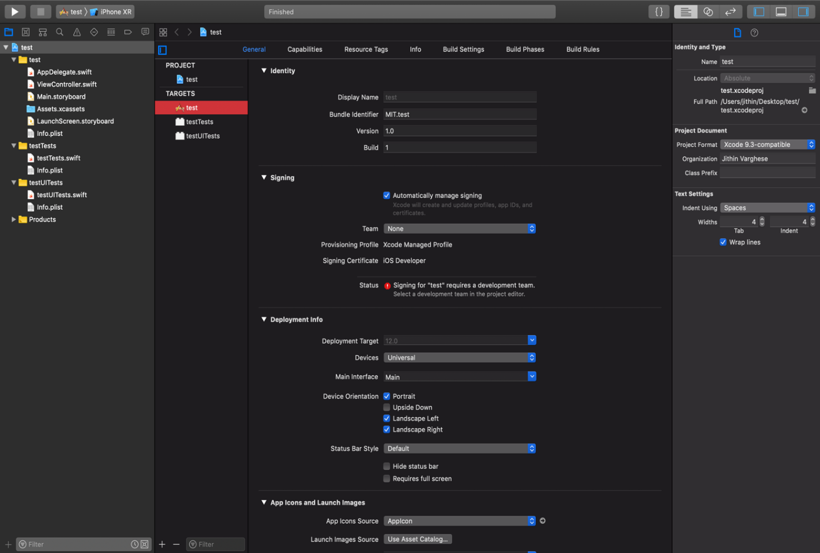

Figure 46 XCode – IDE

## **Apple Store**

iOS application can be downloaded from apple store. Apple store is created by Apple Inc. After completing the application developers publish the app in to the apple store. Where iPhone users can download application to their Phone.

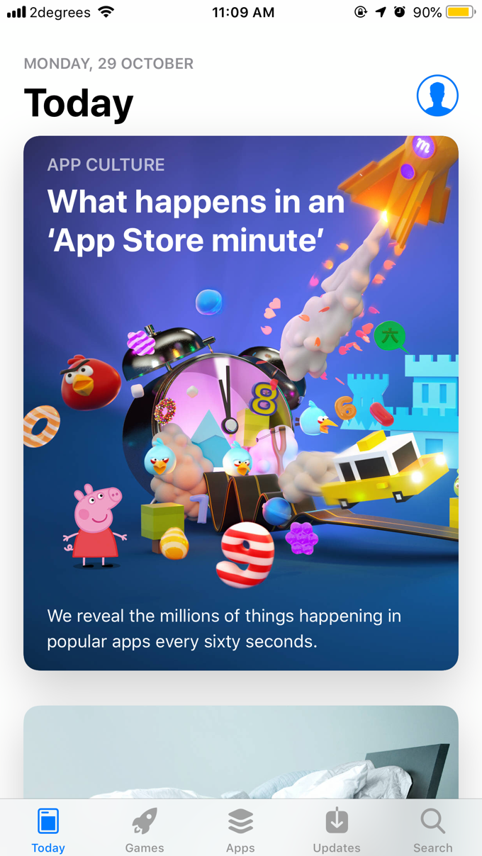

Figure 47 Apple App Store

## **JavaScript Object Notation (JSON)**

JSON is used as a hub between the presentation layer and data layer to be clearer. JSON is used to exchange the data between the mobile application and server, it transfers the data in text format. We use PHP as the languages to get the JSON format text, PHP have built in function to get the JSON (w3schools, JSON - Introduction, n.d.) (w3schools, JSON PHP, n.d.).

## **Microsoft SQL Server**

SQL Server is an integral part of data platform from Microsoft and it is categorised as Operational Database Management Systems (ODBMS). There many services associated with SQL Server, but the focus is the Database engine service which is used for storing, processing and securing data. It gives precise access to its users and swift transaction processing methodology is mitigate the challenging need of the industries data depended applications. Database engine creates databases based on relations databases for OLTP and OLAP based on schema objects such as tables for data storage, indexes, vies and stored procedures used for managing and securing the data. For managing the schema objects, we can use SQL Server Management studio, SQL Server profiler to collect the server-based events (Microsoft, 2017).

# Project Risks

As any other project our project is also having risks which need to mitigate it and produce a value added best in class app by the end of the project time limit.

## **Time Constraints**

Time is a major constrain because both of us are new to app development using iOS but if this is developed by a professional 8 weeks is not a concern rather it was more than enough. We must mitigate this risk by collaborating the learning and need to arrange frequent meeting either face to face or online for sharing the knowledge. We have a definite plan to manage the individual tasks on Gantt Chart, which will be used as our reference so that we can check actual against planned so that we will get an idea about our progression.

## **Lack of Communication**

Communication is a major issue as any other project even though our team is only 2 members either of us must be freely available on communication mediums such as email, mobile and person-to-person meetings. Sometime over phone or email will not work out for transferring an idea hence persons-to-person. Individuals involved such as developer and supervisor meetings can be arranged for clarifications and suggestions. This shows the relevance of the documentation of all stages of SDLC. So that we can share it to supervisor and each other. For mitigating this risk, we have planned to communicate each other on day-to-day basis or else every alternate day.

## **Hardware Failure**

Computer is not 100% reliable hardware it can give wide variety of failures hence, to handle this risk we have decided to keep our documents and source code in Github and our personal google cloud.

## **Lack of Experience**

We both are students with different background and streams with minimal designing, coding, testing and deploying experience in iOS. Hence it will require a great deal of studying iOS, XCode and JASON & PHP. Then we are anticipating that we will have to phase the major hassles and obstructions such as bugs, logical bugs and some time we might require professional assistance to move forward. To mitigate this risk, we need to do lots of background study which is available on google and apple documentations and if we need to be an expert then we need to run an extra mile which is taking dedicated extra effort in timely manner. Which will help us in our future professional life.

# Planning Required

## **Responsibilities**

**Project Leader:** Sushil Cherian

**Project Developer:** Jithin Varghese

**Responsibilities of Project Leader**

1. Project Planning and management using Gantt Chart
2. Arrange Project meetings with Supervisor
3. Arrange Project team meetings
4. Creating Power Point presentations of the project
5. Planning and assigning work allocation
6. Proofreading of the documents on pear to pear basis
7. Design review
8. Assisting Jithin on Testing the app

**Responsibilities of the Project Developer**

1. Short listing and selecting the Software Development methodology
2. Designing the app
3. Coding and testing the app
4. Developing a video of the app which is developed
5. Proofreading of the document on pear to pear basis

# Gantt Chart

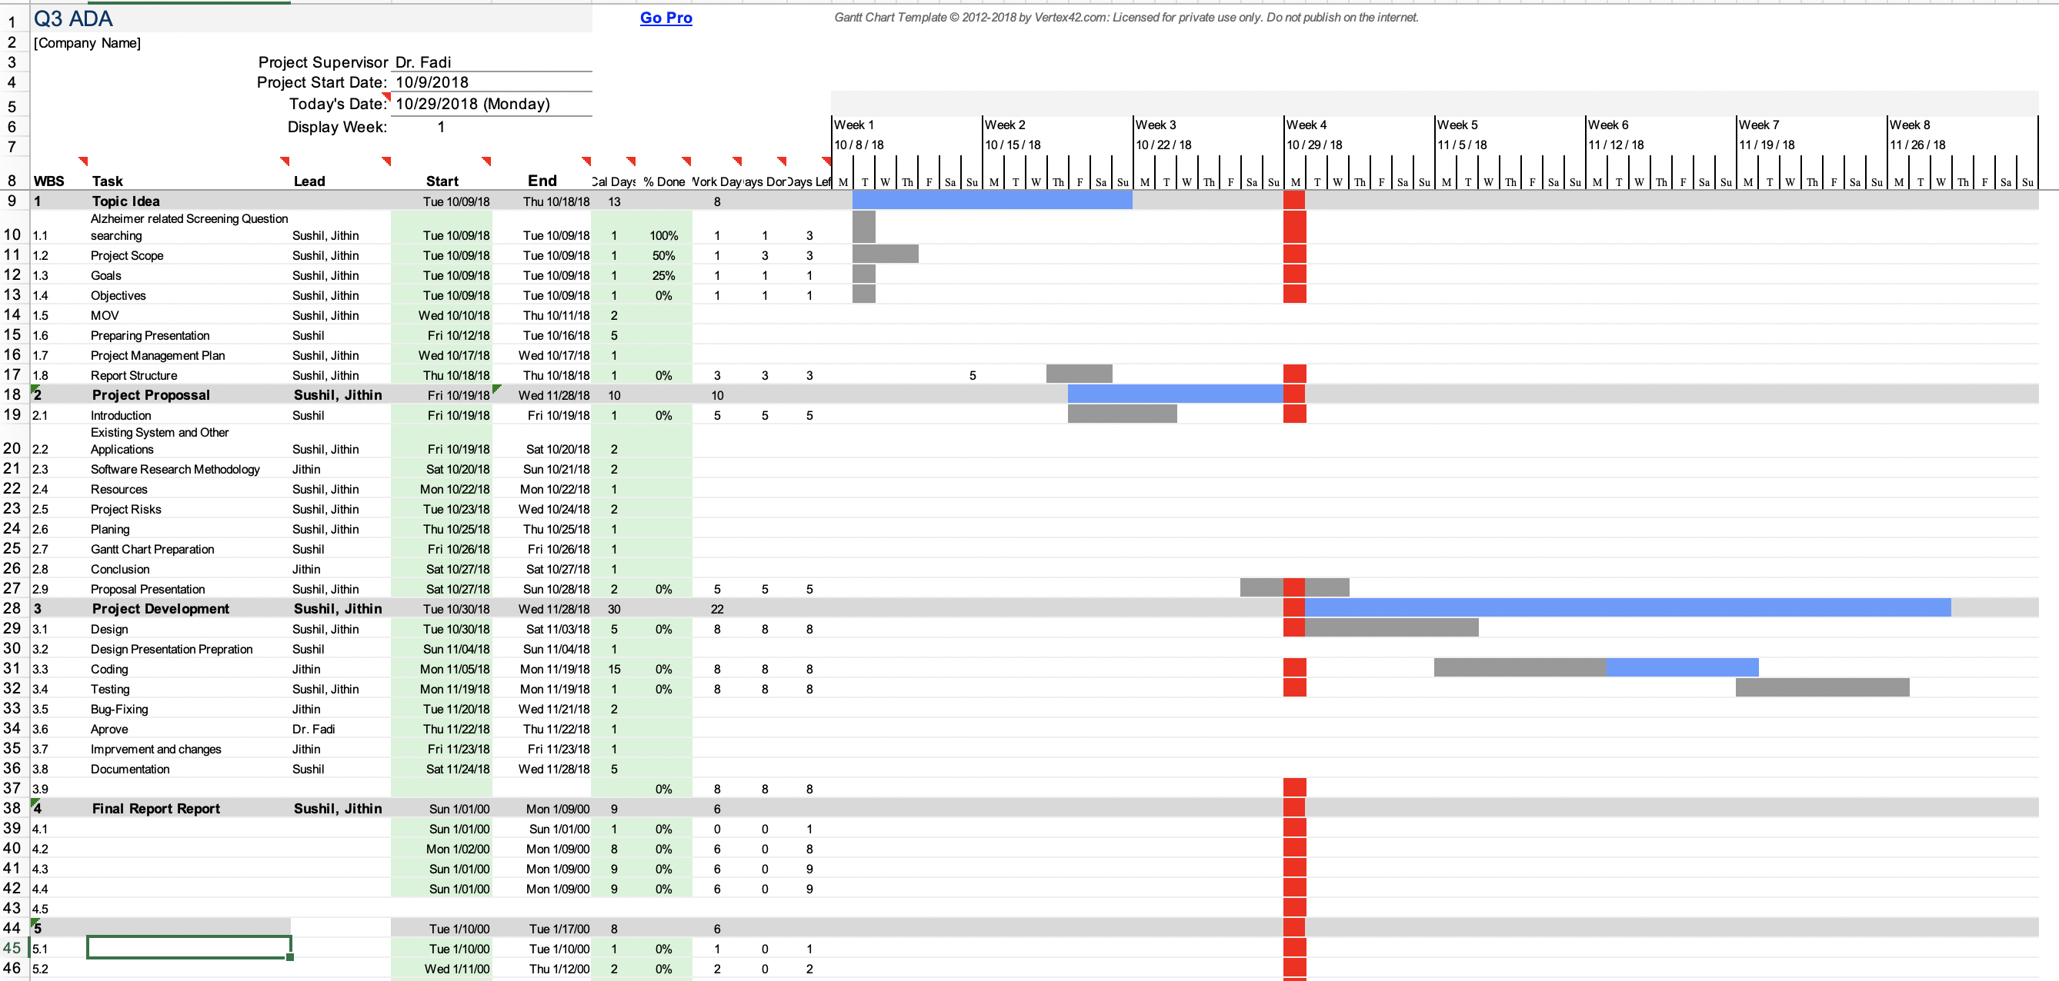

# Conclusion

There is common saying “**health** is **wealth**”, so it is very important to be healthier for the better life. We believe that by this proposal, so we are taking a small effort to help the society in terms of social aspects as Alzheimer’s major concern in dementia which helps patients and their family members. There is an economic impact as well, that is even if a healthier person has doubt on his mental health or rather Dementia’s Alzheimer part they need to visit a physician but for a pre-diagnosis app will give them an idea of their health which save those time and money. Moreover, our app is going to publish in app store for free.

# References

alec.hewitt9@gmail.com. (2017, September 2). Dementia & Alzheimer's Memory Diagnosis Test. *Dementia Analysis- MMSE*. Retrieved from https://play.google.com/store/apps/details?id=com.alzheimers_mme&rdid=com.alzheimers_mme

alliancesoftware. (n.d.). *alliance software*. Retrieved from alliancesoftware: https://www.alliancesoftware.com.au/introduction-software-development-methodologies/

Anderson, K. (2017, 10 4). *What is Rapid Application Development and When Should You Use It?* Retrieved from blog.capterra.com: https://blog.capterra.com/what-is-rapid-application-development/

Andrew Rosenzweig, M. (2018, June 28). *The Mini-Mental State Exam (MMSE) as an Alzheimer's Screening Test*. Retrieved from Verywell Health: https://www.verywellhealth.com/mini-mental-state-exam-as-an-alzheimers-screening-test-98623

Apple. (2018). *About Swift*. Retrieved from Swift: https://swift.org/about/#swiftorg-and-open-source

Apple. (2018). *features*. Retrieved from Developer.apple: https://developer.apple.com/xcode/features/

Association, A. (2018). *What Is Alzheimer's?* Retrieved from www.alz.org: https://www.alz.org/alzheimers-dementia/what-is-alzheimers

CENTER, B. U. (2015, August 12). *DementiAssist* . Retrieved from apple store: https://itunes.apple.com/nz/app/dementiassist/id926516122#?platform=iphone

Ericksen, P. (2016, August 7). *Alzheimer's and Dementia Tips for Families*. Retrieved from apple store: https://itunes.apple.com/nz/app/alzheimers-and-dementia-tips-for-families/id999143350?mt=8

LLC, B. B. (2017, September 15). *Alzheimer’s Disease Pocketcard* . Retrieved from App store: https://itunes.apple.com/nz/app/alzheimers-disease-pocketcard/id845039544?mt=8

Microsoft. (2017). *SQL Server Database Engine*. Retrieved from docs.microsoft.com: https://docs.microsoft.com/en-us/sql/database-engine/sql-server-database-engine-overview?view=sql-server-2017

Professionals, A. o. (n.d.). *IT knowledge Portal*. Retrieved from itinfo: http://www.itinfo.am/eng/software-development-methodologies/

s.r.o., P. H. (2017, April 7). *Dementia Test - risk calculator of dementia*. Retrieved from Apple store: https://itunes.apple.com/us/app/dementia-test-risk-calculator-of-dementia/id1014958634?mt=8

Spn, N. T. (2017, January 3). *My Brain - Check Alzheimer*. Retrieved from play.google.com: https://play.google.com/store/apps/details?id=namantiwari.mybrain

Tanrıverdi, Y. (2016, September 3). *MMSE*. Retrieved from Google Play Store: https://play.google.com/store/apps/details?id=com.yasintanriverdi.mmse

Team, l. C. (2018, May 23). *4 Phases of Rapid Application Development Methodology* . Retrieved from www.lucidchart.com: https://www.lucidchart.com/blog/rapid-application-development-methodology

w3schools. (n.d.). *JSON - Introduction*. Retrieved from w3schools: https://www.w3schools.com/js/js_json_intro.asp

w3schools. (n.d.). *JSON PHP*. Retrieved from w3schools: https://www.w3schools.com/js/js_json_php.asp

Wascher, T. (2018, October 25). *Google Play Store*. Retrieved from Soca Dementia-Test: https://play.google.com/store/apps/details?id=appinventor.ai_TOMMYBONN2011.soca_english